|  |  |  |
| --- | --- | --- |
| Защищено:  Гапанюк Ю.Е.    "__"_____________2021 г. |  | Демонстрация:  Гапанюк Ю.Е.  "__"_____________2021 г. |

**Отчет по домашнему заданию по курсу**

**Разработка интернет-приложений**

**ГУИМЦ**

#### Тема работы: " Разработка мобильного приложения "

55

(количество листов)

Вариант № **1**

|  |  |
| --- | --- |
| ИСПОЛНИТЕЛЬ: |  |
| студент группы ИУ5Ц-74Б | _____________________ |
|  | (подпись) |
| Карпов И.Е. | "__"_____________2021 г. |

Москва, МГТУ - 2021

_____________________________________________________________________________________________

**СОДЕРЖАНИЕ**

1. Описание задания 3

2. Текст программы 4

3. Связь приложения с API по доменному имени 36

4. Результаты выполнения программы 38

# Описание задания

На основе методических указаний разработайте мобильное приложение на языке Kotlin (платформа Android) или языке Swift (платформа iOS). Для создания приложения необходимо решить следующие задачи:

1. Создать стартовый проект мобильного приложения.
2. Добавить компонент таблицы в Ваше приложение.
3. Добавить подключение из мобильного приложения к веб-сервису, разработанному в лабораторной работе №6.
4. Наполнить таблицу элементами, полученными из вашего веб-сервиса: с помощью запросов к API получить из него данные.
5. Разработать дополнительный экран с UI компонентами для отображения детальной информации об элементе таблицы при касании по нему.

Дополнительное задание:

Реализовать возможности редактирования, добавления и удаления данных таблицы в мобильном приложении с помощью запросов к веб-сервису.

# Текст программы

**Конфиг HTTP reverse proxy (IIS) C:\inetpub\DZ-RIP\web.config**

<?xml version=**"1.0"** encoding=**"UTF-8"**?>

<configuration>

<system.webServer>

<rewrite>

<rules>

<rule name=**"ProxyToYouTrack"** patternSyntax=**"ECMAScript"** stopProcessing=**"true"**>

<match url=**"(.*)"** negate=**"false"** />

<action type=**"Rewrite"** url=**"http://localhost:8000/{R:1}"** appendQueryString=**"true"** logRewrittenUrl=**"true"** />

<conditions>

<add input=**"{SERVER_PORT}"** pattern=**"443"** />

</conditions>

</rule>

<rule name=**"redir to ssl"** enabled=**"true"** stopProcessing=**"true"**>

<match url=**"(.*)"** />

<action type=**"Redirect"** url=**"https://dz-rip.pc.sccraft.ru"** />

</rule>

</rules>

<outboundRules>

<preConditions>

<preCondition name=**"ResponseIsHtml1"**>

<add input=**"{RESPONSE_CONTENT_TYPE}"** pattern=**"^text/html"** />

<add input=**"{RESPONSE_CONTENT_TYPE}"** pattern=**"^application/json"** />

</preCondition>

</preConditions>

</outboundRules>

</rewrite>

<security>

<requestFiltering allowDoubleEscaping=**"true"** />

</security>

</system.webServer>

<system.web>

<httpRuntime requestPathInvalidCharacters=**""** />

</system.web>

</configuration>

**app/src/main/java/ru/sccraft/bmstulabs/rip/animals/API_URL.kt**

package ru.sccraft.bmstulabs.rip.animals  
  
const val *API_URL* = "https://dz-rip.pc.sccraft.ru"  
  
*/*  
* dz.rip.pc.sccraft.ru - субдомен, внесённый в DNS сервер, обслуживающий зону sccraft.ru  
* На этот суюдлмен был получен SSL сертификат, который требует Android  
* Связь с API осуществляется через IIS HTTP Proxy. Подробнее: https://habr.com/ru/post/240495/  
*/*

**app/src/main/java/ru/sccraft/bmstulabs/rip/animals/MainActivity.kt**

package ru.sccraft.bmstulabs.rip.animals  
  
import android.content.Intent  
import android.net.Uri  
import android.os.Bundle  
import android.util.Log  
import android.view.Menu  
import android.view.MenuItem  
import android.view.View  
import android.widget.*  
import androidx.appcompat.app.AlertDialog  
import androidx.appcompat.app.AppCompatActivity  
import retrofit2.Call  
import ru.sccraft.bmstulabs.rip.animals.databinding.ActivityMainBinding  
  
  
class MainActivity : AppCompatActivity() {  
  
 private lateinit var binding: ActivityMainBinding  
 private lateinit var pb: ProgressBar  
 private lateinit var lw: ListView  
  
 override fun onCreate(savedInstanceState: Bundle?) {  
 super.onCreate(savedInstanceState)  
  
 binding = ActivityMainBinding.inflate(*layoutInflater*)  
 setContentView(binding.*root*)  
  
 setSupportActionBar(binding.toolbar)  
  
 pb = findViewById(R.id.*progressBar_main*)  
 lw = findViewById(R.id.*listView_animals*)  
  
 binding.fab.setOnClickListener **{** view **->** val intent = Intent(this, AnimalAddActivity::class.*java*)  
 startActivity(intent)  
 **}** *//////////////////* получить_данные_из_API()  
 }  
  
 override fun onCreateOptionsMenu(menu: Menu): Boolean {  
 *// Inflate the menu; this adds items to the action bar if it is present.  
 menuInflater*.inflate(R.menu.*menu_main*, menu)  
 return true  
 }  
  
 override fun onOptionsItemSelected(item: MenuItem): Boolean {  
 *// Handle action bar item clicks here. The action bar will  
 // automatically handle clicks on the Home/Up button, so long  
 // as you specify a parent activity in AndroidManifest.xml.* return when (item.*itemId*) {  
 R.id.*action_about* -> {  
 val intent = Intent(this@MainActivity, AboutActivity::class.*java*)  
 startActivity(intent)  
 return true  
 }  
 R.id.*action_update* -> {  
 получить_данные_из_API()  
 return true  
 }  
 else -> super.onOptionsItemSelected(item)  
 }  
 }  
  
 private fun получить_данные_из_API() {  
 показать_индикатор_загрузки()  
 NetworkService.getInstance()  
 .*jsonApi* .*allAnimals* .enqueue(object : retrofit2.Callback<List<Animal?>?> {  
 override fun onResponse(  
 call: Call<List<Animal?>?>,  
 response: retrofit2.Response<List<Animal?>?>  
 ) {  
 val animalList = response.body()  
 if (animalList != null) {  
 Log.i("MainActivity", "Данные из API успешно получены!")  
 val список_животных = ArrayList<Animal>()  
 for (a in animalList) {  
 if (a != null)  
 список_животных.add(a)  
 }  
 val адаптер = AnimalAdapter(this@MainActivity, список_животных)  
 lw.*adapter* = адаптер  
 lw.setOnItemClickListener **{** parent, view, position, id **->** val intent = Intent(this@MainActivity, AnimalInfoActivity::class.*java*)  
 if (animalList[position] != null) {  
 intent.putExtra("animal_name", animalList[position]!!.*animal_name*)  
 intent.putExtra("animal_type", animalList[position]!!.*animal_type*)  
 intent.putExtra("animal_photo", animalList[position]!!.*animal_photo*)  
 intent.putExtra("animal_id", animalList[position]!!.*id*)  
 }  
 startActivity(intent)  
 **}** }  
 else {  
 *//404 - Прокси-сервер выключен //502 - прокси-сервер включён, но API выключен* val error_arrayList = ArrayList<String>(1)  
 error_arrayList.add("Не удалось получить данные!")  
 val adapter = ArrayAdapter(this@MainActivity, android.R.layout.*simple_list_item_1*, android.R.id.*text1*, error_arrayList)  
 lw.*adapter* = adapter  
 lw.setOnItemClickListener **{** parent, view, position, id **->}** показать_диалог_ошибки_загрузки()  
 }  
 скрыть_индикатор_загрузки()  
 }  
  
 override fun onFailure(call: Call<List<Animal?>?>, t: Throwable) {  
 *//Что-то пошло не так…* Log.e("MainActivity", "Не удалось получить данные из API")  
 t.printStackTrace()  
 показать_диалог_ошибки_загрузки()  
 скрыть_индикатор_загрузки()  
 }  
 })  
 }  
  
 private fun показать_диалог_ошибки_загрузки() {  
 val builder = AlertDialog.Builder(this)  
 builder.setTitle(R.string.*dialog_fail_download_title*)  
 builder.setMessage(R.string.*dialog_fail_download_text*)  
  
 builder.setPositiveButton(R.string.*retry*) **{** dialog, id **->** получить_данные_из_API()  
 **}** builder.setNegativeButton(  
 android.R.string.*cancel*) **{** dialog, id **->  
 }** builder.setNeutralButton(R.string.*open_API*) **{**dialog, id**->** val ссылка_на_API = Uri.parse("$*API_URL*/")  
 val открыть_API_в_браузере = Intent(Intent.*ACTION_VIEW*, ссылка_на_API)  
 startActivity(открыть_API_в_браузере)  
 **}** builder.show()  
 }  
  
 private fun показать_индикатор_загрузки() {  
 lw.*visibility* = View.*GONE* pb.*visibility* = View.*VISIBLE* }  
  
 private fun скрыть_индикатор_загрузки() {  
 lw.*visibility* = View.*VISIBLE* pb.*visibility* = View.*GONE* }  
}

**app/src/main/java/ru/sccraft/bmstulabs/rip/animals/Animal.java**

package ru.sccraft.bmstulabs.rip.animals;  
  
import androidx.annotation.NonNull;  
  
import com.google.gson.annotations.Expose;  
import com.google.gson.annotations.SerializedName;  
  
public class Animal {  
 @SerializedName("id")  
 @Expose  
 private int id;  
  
 @SerializedName("animal_name")  
 @Expose  
 private String animal_name;  
  
 @SerializedName("animal_type")  
 @Expose  
 private String animal_type;  
  
 @SerializedName("animal_photo")  
 @Expose  
 private String animal_photo;  
  
 public int getId() {  
 return id;  
 }  
  
 public void setId(int id) {  
 this.id = id;  
 }  
  
 public String getAnimal_name() {  
 return animal_name;  
 }  
  
 public String getAnimal_type() {  
 return animal_type;  
 }  
  
 public String getAnimal_photo() {  
 return animal_photo;  
 }  
  
 public void setAnimal_name(String animal_name) {  
 this.animal_name = animal_name;  
 }  
  
 public void setAnimal_type(String animal_type) {  
 this.animal_type = animal_type;  
 }  
  
 public void setAnimal_photo(String animal_photo) {  
 this.animal_photo = animal_photo;  
 }  
  
 @NonNull  
 @Override  
 public String toString() {  
 return animal_name + "\n" + animal_type;  
 }  
}

**app/src/main/java/ru/sccraft/bmstulabs/rip/animals/AnimalAdapter.kt**

package ru.sccraft.bmstulabs.rip.animals  
  
import android.content.Context  
import android.view.LayoutInflater  
import android.view.View  
import android.view.ViewGroup  
import android.widget.BaseAdapter  
import android.widget.ImageView  
import android.widget.TextView  
import com.bumptech.glide.Glide  
  
class AnimalAdapter(context: Context, private val животные: List<Animal>) : BaseAdapter() {  
  
 private val lInflater: LayoutInflater  
 private val c: Context  
  
 init {  
 lInflater = context.getSystemService(Context.*LAYOUT_INFLATER_SERVICE*) as LayoutInflater  
 c = context  
 }  
  
 override fun getCount(): Int {  
 return животные.size  
 }  
  
 override fun getItem(i: Int): Any {  
 return животные[i]  
 }  
  
 override fun getItemId(i: Int): Long {  
 return i.toLong()  
 }  
  
 override fun getView(i: Int, view: View?, viewGroup: ViewGroup): View {  
 *// используем созданные, но не используемые view* var вью: View? = view  
 if (вью == null) {  
 вью = lInflater.inflate(R.layout.*item_list_animal*, viewGroup, false)  
 }  
 val животное = получить_животное(i)  
 val кличка = вью!!.findViewById<TextView>(R.id.*list_animal_name*)  
 val вид = вью.findViewById<TextView>(R.id.*list_animal_type*)  
 val фото = вью.findViewById<ImageView>(R.id.*list_animal_photo*)  
  
 кличка.*text* = животное.*animal_name* вид.*text* = животное.*animal_type* Glide.with(c).load(животное.*animal_photo*).into(фото)  
 return вью  
 }  
  
 private fun получить_животное(позиция: Int): Animal {  
 return getItem(позиция) as Animal  
 }  
}

**app/src/main/java/ru/sccraft/bmstulabs/rip/animals/AnimalAddActivity.kt**

package ru.sccraft.bmstulabs.rip.animals  
  
import android.os.Bundle  
import android.util.Log  
import android.view.Menu  
import android.view.MenuItem  
import android.widget.EditText  
import android.widget.Toast  
import androidx.appcompat.app.AppCompatActivity  
import okhttp3.OkHttpClient  
import retrofit2.Call  
import retrofit2.Callback  
import retrofit2.Response  
import retrofit2.Retrofit  
import retrofit2.converter.gson.GsonConverterFactory  
  
class AnimalAddActivity : AppCompatActivity() {  
  
 private var кличка_животного :EditText? = null  
 private var вид_животного :EditText? = null  
 private var фото_животного :EditText? = null  
  
 override fun onCreate(savedInstanceState: Bundle?) {  
 super.onCreate(savedInstanceState)  
 setContentView(R.layout.*activity_animal_add*)  
 setTitle(R.string.*activity_animal_add*)  
  
 кличка_животного = findViewById(R.id.*editText_animal_name*)  
 вид_животного = findViewById(R.id.*editText_animal_type*)  
 фото_животного = findViewById(R.id.*editText_animal_photo*)  
 }  
  
 override fun onCreateOptionsMenu(menu: Menu?): Boolean {  
 *menuInflater*.inflate(R.menu.*menu_animal_add*, menu)  
 return true  
 }  
  
 override fun onOptionsItemSelected(item: MenuItem): Boolean {  
 *// Handle action bar item clicks here. The action bar will  
 // automatically handle clicks on the Home/Up button, so long  
 // as you specify a parent activity in AndroidManifest.xml.* return when (item.*itemId*) {  
 R.id.*action_save* -> {  
 ServiceBuilder.buildService(POST_RestApi::class.*java*)  
 addNewAnimal()  
 return true  
 }  
 else -> super.onOptionsItemSelected(item)  
 }  
 }  
  
  
 *//Отправка POST на сервер* private fun addNewAnimal() {  
 val apiService = RestApiService()  
 val animal = Animal()  
 animal.*id* = 0  
 animal.*animal_name* = кличка_животного!!.*text*.toString()  
 animal.*animal_type* = вид_животного!!.*text*.toString()  
 animal.*animal_photo* = фото_животного!!.*text*.toString()  
  
 apiService.addUser(animal) **{** if (**it**?.*id* != null) {  
 *//Завершаеи Activity без проверки полученного объекта* finish()  
 } else {  
 Log.e("AnimalAddActivity", getString(R.string.*fail_add_animal*))  
 Toast.makeText(*applicationContext*, R.string.*fail_add_animal*, Toast.*LENGTH_LONG*).show()  
 }  
 **}** }  
  
 */////////////////////////* private object ServiceBuilder {  
 private val client = OkHttpClient.Builder().build()  
  
 private val retrofit = Retrofit.Builder()  
 .baseUrl(*API_URL*)  
 .addConverterFactory(GsonConverterFactory.create())  
 .client(client)  
 .build()  
  
 fun<T> buildService(service: Class<T>): T{  
 return retrofit.create(service)  
 }  
 }  
  
 *///////////////* private class RestApiService {  
 fun addUser(userData: Animal, onResult: (Animal?) -> Unit){  
 val retrofit = ServiceBuilder.buildService(POST_RestApi::class.*java*)  
 retrofit.addAnimal(userData).enqueue(  
 object : Callback<Animal> {  
 override fun onFailure(call: Call<Animal>, t: Throwable) {  
 onResult(null)  
 }  
 override fun onResponse(call: Call<Animal>, response: Response<Animal>) {  
 val addedAnimal = response.body()  
 onResult(addedAnimal)  
 }  
 }  
 )  
 }  
 }  
}

**app/src/main/java/ru/sccraft/bmstulabs/rip/animals/AnimalInfoActivity.kt**

package ru.sccraft.bmstulabs.rip.animals  
  
import android.content.DialogInterface  
import android.content.Intent  
import android.net.Uri  
import android.os.AsyncTask  
import android.os.Bundle  
import android.view.Menu  
import android.view.MenuItem  
import android.widget.ImageView  
import android.widget.TextView  
import androidx.appcompat.app.AlertDialog  
import androidx.appcompat.app.AppCompatActivity  
import com.bumptech.glide.Glide  
import okhttp3.MediaType  
import okhttp3.OkHttpClient  
import okhttp3.Request  
import okhttp3.RequestBody  
import java.io.IOException  
  
  
class AnimalInfoActivity : AppCompatActivity() {  
  
 companion object {  
 var animal_name = ""  
 var animal_type = ""  
 var animal_photo = ""  
 var animal_id = 0  
 }  
  
 private var показывать_диалог_удаления = false  
  
 private lateinit var tv_name :TextView  
 private lateinit var tv_type :TextView  
 private lateinit var img :ImageView  
  
 override fun onCreate(savedInstanceState: Bundle?) {  
 super.onCreate(savedInstanceState)  
 setContentView(R.layout.*activity_animal_info*)  
 setTitle(getString(R.string.*title_activity_animalInfo*))  
 setupActionBar()  
  
 if (savedInstanceState == null) {  
 animal_name = *intent*.getStringExtra("animal_name")!!  
 animal_type = *intent*.getStringExtra("animal_type")!!  
 animal_photo = *intent*.getStringExtra("animal_photo")!!  
 animal_id = *intent*.getIntExtra("animal_id", 0)  
 }  
 else {  
 показывать_диалог_удаления = savedInstanceState.getBoolean("delete_dialog")  
 }  
  
 tv_name = findViewById(R.id.*info_animal_name*)  
 tv_type = findViewById(R.id.*info_animal_type*)  
 img = findViewById(R.id.*info_animal_photo*)  
  
 tv_name.*text* = animal_name  
 tv_type.*text* = animal_type  
 Glide.with(this).load(animal_photo).into(img)  
 }  
  
 private fun setupActionBar() {  
 val actionBar = *supportActionBar* actionBar?.setDisplayHomeAsUpEnabled(true)  
 }  
  
 override fun onCreateOptionsMenu(menu: Menu): Boolean {  
 *// Inflate the menu; this adds items to the action bar if it is present.  
 menuInflater*.inflate(R.menu.*menu_animal_info*, menu)  
 return true  
 }  
  
 override fun onOptionsItemSelected(item: MenuItem): Boolean {  
 *// Handle action bar item clicks here. The action bar will  
 // automatically handle clicks on the Home/Up button, so long  
 // as you specify a parent activity in AndroidManifest.xml.* return when (item.*itemId*) {  
 R.id.*action_delete* -> {  
 показывать_диалог_удаления = true  
 показать_диалог_удаления()  
 return true  
 }  
 else -> super.onOptionsItemSelected(item)  
 }  
 }  
  
 fun удалить_животное() {  
 class Поток : AsyncTask<Void, Void, Int>() {  
  
 override fun doInBackground(vararg params: Void): Int {  
 val client = OkHttpClient()  
 val builder = Request.Builder()  
 .url("$*API_URL*/animals/$animal_id/")  
 .delete(  
 RequestBody.create(  
 MediaType.parse("application/json; charset=utf-8"), "{}"  
 )  
 )  
 val request = builder.build()  
 try {  
 val response = client.newCall(request).execute()  
 val string = response.body()!!.string()  
 *// TODO use your response* } catch (e: IOException) {  
 e.printStackTrace()  
 }  
  
 return 0  
 }  
  
 override fun onPostExecute(i: Int) {  
 super.onPostExecute(i)  
 finish()  
 }  
 }  
  
 val поток = Поток()  
 поток.execute()  
 }  
  
 override fun onSaveInstanceState(outState: Bundle) {  
 super.onSaveInstanceState(outState)  
 outState.putBoolean("delete_dialog", показывать_диалог_удаления)  
 }  
  
 private fun показать_диалог_удаления() {  
 val builder = AlertDialog.Builder(this)  
 builder.setTitle(R.string.*dialog_delete_title*)  
 builder.setMessage(R.string.*dialog_delete_text*)  
 builder.setCancelable(true)  
  
 builder.setPositiveButton(R.string.*yes*) **{** dialog, id **->** удалить_животное()  
 **}** builder.setNegativeButton(R.string.*no*) **{** dialog, id **->** показывать_диалог_удаления = false  
 **}** builder.setOnCancelListener **{** dialogInterface: DialogInterface **->** показывать_диалог_удаления = false  
 **}** builder.show()  
 }  
}

**app/src/main/java/ru/sccraft/bmstulabs/rip/animals/JSONPlaceHolderApi.java**

package ru.sccraft.bmstulabs.rip.animals;  
  
import java.util.List;  
  
import retrofit2.Call;  
import retrofit2.http.GET;  
  
public interface JSONPlaceHolderApi {  
 @GET("/animals")  
 public Call<List<Animal>> getAllAnimals();  
}

**app/src/main/java/ru/sccraft/bmstulabs/rip/animals/NetworkService.java**

package ru.sccraft.bmstulabs.rip.animals;  
  
import retrofit2.Retrofit;  
import retrofit2.converter.gson.GsonConverterFactory;  
  
public class NetworkService {  
 private static NetworkService *mInstance*;  
 private static final String *BASE_URL* = API_URLKt.*API_URL*;  
 private final Retrofit mRetrofit;  
  
 private NetworkService() {  
 mRetrofit = new Retrofit.Builder()  
 .baseUrl(*BASE_URL*)  
 .addConverterFactory(GsonConverterFactory.*create*())  
 .build();  
 }  
  
 public static NetworkService getInstance() {  
 if (*mInstance* == null) {  
 *mInstance* = new NetworkService();  
 }  
 return *mInstance*;  
 }  
 public JSONPlaceHolderApi getJSONApi() {  
 return mRetrofit.create(JSONPlaceHolderApi.class);  
 }  
}

**app/src/main/java/ru/sccraft/bmstulabs/rip/animals/POST_RestApi.kt**

package ru.sccraft.bmstulabs.rip.animals  
  
import retrofit2.Call  
import retrofit2.http.Body  
import retrofit2.http.Headers  
import retrofit2.http.POST  
  
interface POST_RestApi {  
  
 @Headers("Content-Type: application/json")  
 @POST("animals/")  
 fun addAnimal(@Body animalData: Animal): Call<Animal>  
}

**app/src/main/java/ru/sccraft/bmstulabs/rip/animals/AboutActivity.kt**

package ru.sccraft.bmstulabs.rip.animals  
  
import android.annotation.SuppressLint  
import android.content.Intent  
import android.content.pm.PackageInfo  
import android.content.pm.PackageManager  
import android.net.Uri  
import android.os.AsyncTask  
import android.os.Bundle  
import android.view.View  
import android.widget.TextView  
import android.widget.Toast  
import androidx.appcompat.app.AppCompatActivity  
import androidx.core.content.pm.PackageInfoCompat.getLongVersionCode  
import java.io.BufferedReader  
import java.io.IOException  
import java.io.InputStreamReader  
  
class AboutActivity : AppCompatActivity(R.layout.*activity_about*) {  
  
 internal var номер_сборки = 0L *//VersionCode* internal var название_версии = "" *//VersionName* internal lateinit var vc: TextView  
 internal lateinit var vn: TextView  
 private var кликни_пять_раз_не_поворачивая_экран: Byte = 0  
 private lateinit var toast: Toast  
  
 @SuppressLint("ShowToast")  
 override fun onCreate(savedInstanceState: Bundle?) {  
 super.onCreate(savedInstanceState)  
 setupActionBar()  
 *title* = getString(R.string.*about*)  
 toast = Toast.makeText(*applicationContext*, "", Toast.*LENGTH_SHORT*)  
 try {  
 название_версии = *packageManager*.getPackageInfo(*packageName*, 0).versionName  
 } catch (e: PackageManager.NameNotFoundException) {  
 e.printStackTrace()  
 }  
  
 try {  
 val информация_о_пакете: PackageInfo = getPackageManager().getPackageInfo(getPackageName(), 0)  
 номер_сборки = getLongVersionCode(информация_о_пакете)  
 } catch (e: PackageManager.NameNotFoundException) {  
 e.printStackTrace()  
 }  
  
 vc = findViewById(R.id.*aboutVersionCode*)  
 vn = findViewById(R.id.*aboutVN*)  
 vc.*text* = номер_сборки.toString()  
 vn.*text* = название_версии  
 кликни_пять_раз_не_поворачивая_экран = 0  
 }  
  
 private fun setupActionBar() {  
 val actionBar = *supportActionBar* actionBar?.setDisplayHomeAsUpEnabled(true)  
 }  
  
 private fun получить_лог_приложения(): String {  
 try {  
 val процесс = Runtime.getRuntime().exec("logcat -d")  
 val bufferedReader = BufferedReader(InputStreamReader(процесс.*inputStream*))  
  
 val лог = StringBuilder()  
 var линия: String? = ""  
 do {  
 линия = bufferedReader.readLine()  
 лог.append("$линия\n")  
 } while (линия != null)  
 return лог.toString()  
 } catch (e: IOException) {  
 e.printStackTrace()  
 return ""  
 }  
  
 }  
  
 fun getLogcat(view: View) {  
 if (кликни_пять_раз_не_поворачивая_экран < 5) {  
 кликни_пять_раз_не_поворачивая_экран++  
 toast.setText(R.string.*onlyForDevelopers*)  
 toast.*duration* = Toast.*LENGTH_LONG* toast.show()  
 if (кликни_пять_раз_не_поворачивая_экран.toInt() != 5) return  
 }  
 toast.cancel()  
 class Поток : AsyncTask<Void, Void, Intent>() {  
  
 override fun doInBackground(vararg params: Void): Intent {  
 val отправить_лог = Intent()  
 отправить_лог.*action* = Intent.*ACTION_SEND* отправить_лог.putExtra(Intent.*EXTRA_TEXT*, получить_лог_приложения())  
 отправить_лог.*type* = "text/plain"  
 return отправить_лог  
 }  
  
 override fun onPostExecute(intent: Intent) {  
 super.onPostExecute(intent)  
 if (intent.resolveActivity(*packageManager*) != null) {  
 startActivity(intent)  
 }  
 }  
 }  
  
 val поток = Поток()  
 поток.execute()  
  
 }  
  
 fun privacy(view: View) {  
 val ссылка_на_политику_конфиденциальности = Uri.parse("https://github.com/sashaqwert/BMSTU_RIP/blob/master/%D0%94%D0%97/%D0%9F%D0%BE%D0%BB%D0%B8%D1%82%D0%B8%D0%BA%D0%B8_%D0%BB%D0%B8%D1%86%D0%B5%D0%BD%D0%B7%D0%B8%D0%B8/Privacy.md")  
 val открыть_политику_конфиденциальности_в_браузере = Intent(Intent.*ACTION_VIEW*, ссылка_на_политику_конфиденциальности)  
 startActivity(открыть_политику_конфиденциальности_в_браузере)  
 }  
  
 fun viewLicense(view: View) {  
 val ссылка_на_лицензию = Uri.parse("https://github.com/sashaqwert/BMSTU_RIP/blob/master/%D0%94%D0%97/%D0%9F%D0%BE%D0%BB%D0%B8%D1%82%D0%B8%D0%BA%D0%B8_%D0%BB%D0%B8%D1%86%D0%B5%D0%BD%D0%B7%D0%B8%D0%B8/LICENSE")  
 val открыть_лицензию_в_браузере = Intent(Intent.*ACTION_VIEW*, ссылка_на_лицензию)  
 startActivity(открыть_лицензию_в_браузере)  
 }  
  
 fun viewSourceCode(view: View) {  
 val ссылка_на_исходный_код = Uri.parse("https://github.com/sashaqwert/BMSTU_RIP/tree/master/%D0%94%D0%97")  
 val открыть_исходный_код_в_браузере = Intent(Intent.*ACTION_VIEW*, ссылка_на_исходный_код)  
 startActivity(открыть_исходный_код_в_браузере)  
 }  
}

**app/src/main/AndroidManifest.xml**

*<?*xml version="1.0" encoding="utf-8"*?>*<manifest xmlns:android="http://schemas.android.com/apk/res/android"  
 package="ru.sccraft.bmstulabs.rip.animals">  
  
 <uses-permission android:name="android.permission.INTERNET" />  
  
 <application  
 android:allowBackup="true"  
 android:icon="@mipmap/ic_launcher"  
 android:label="@string/app_name"  
 android:roundIcon="@mipmap/ic_launcher_round"  
 android:supportsRtl="true"  
 android:theme="@style/Theme.Животные">  
 <activity  
 android:name=".AnimalAddActivity"  
 android:exported="false" />  
 <activity  
 android:name=".AnimalInfoActivity"  
 android:exported="false">  
 <meta-data  
 android:name="android.support.PARENT_ACTIVITY"  
 android:value=".MainActivity" />  
 </activity>  
 <activity  
 android:name=".AboutActivity"  
 android:exported="false">  
 <meta-data  
 android:name="android.support.PARENT_ACTIVITY"  
 android:value=".MainActivity" />  
 </activity>  
 <activity  
 android:name=".MainActivity"  
 android:exported="true"  
 android:label="@string/app_name"  
 android:theme="@style/Theme.Животные.NoActionBar">  
 <intent-filter>  
 <action android:name="android.intent.action.MAIN" />  
  
 <category android:name="android.intent.category.LAUNCHER" />  
 </intent-filter>  
 </activity>  
 </application>  
  
</manifest>

**app/src/main/res/values/strings.xml**

<resources>  
 <string name="app_name">Животные</string>  
 <string name="action_settings">Настройки</string>  
 *<!-- Strings used for fragments for navigation -->* <string name="first_fragment_label">Животные</string>  
 <string name="second_fragment_label">Second Fragment</string>  
  
 <string name="version">"Версия: "</string>  
 <string name="versionCode">"Номер сборки: "</string>  
 <string name="license">"Лицензия: "</string>  
 <string name="privacy">Политика конфиденциальности</string>  
 <string name="license_button">Просмотреть лицензию</string>  
 <string name="sourceCode">Исходный код</string>  
 <string name="send_logcat">Отправить лог</string>  
 <string name="about">О программе</string>  
 <string name="onlyForDevelopers">Данная функция предназначена только для разработчиков!</string>  
 <string name="animal_name">Кличка</string>  
 <string name="animal_type">Вид животного</string>  
 <string name="animal_photo_alternative_text">Фото животного</string>  
 <string name="title_activity_animalInfo">О животном</string>  
 <string name="animal_photo_url">Ссылка на картинку (https://…)</string>  
 <string name="action_save">Сохранить</string>  
 <string name="dialog_fail_download_text">Проверьте, подключено ли ваше Android устройство (или эмулятор) к интернету и повторите попытку.\nВ настоящее время приложение поддерживает только HTTPS трафик.</string>  
 <string name="dialog_fail_download_title">Ошибка загрузки данных</string>  
 <string name="retry">Попробывать ещё раз</string>  
 <string name="activity_animal_add">Новое животное</string>  
 <string name="fail_add_animal">Не удалось добавить новое животное!</string>  
 <string name="action_update">Обновить</string>  
 <string name="developer">"Разработчик: "</string>  
 <string name="developer_fio">Карпов И. Е.</string>  
 <string name="developer_group">"Группа: "</string>  
 <string name="developer_group_value">ИУ5Ц-74Б</string>  
 <string name="action_delete">Удалить</string>  
 <string name="open_API">Открыть API</string>  
 <string name="yes">Да</string>  
 <string name="no">Нет</string>  
 <string name="dialog_delete_title">Удалить животное?</string>  
 <string name="dialog_delete_text">Текущее животное будет безвозвратно удалено для всех пользователей приложения.\nВы действительно хотите продолжить?</string>  
</resources>

**app/src/main/res/values/colors.xml**

*<?*xml version="1.0" encoding="utf-8"*?>*<resources>  
 <color name="purple_200">#FFBB86FC</color>  
 <color name="purple_500">#FF6200EE</color>  
 <color name="purple_700">#FF3700B3</color>  
 <color name="teal_200">#FF03DAC5</color>  
 <color name="teal_700">#FF018786</color>  
 <color name="black">#FF000000</color>  
 <color name="white">#FFFFFFFF</color>  
</resources>

**app/src/main/res/values/dimens.xml**

<resources>  
 <dimen name="fab_margin">16dp</dimen>  
</resources>

**app/src/main/res/values-land/dimens.xml**

<resources>  
 <dimen name="fab_margin">48dp</dimen>  
</resources>

**app/src/main/res/values-w1240dp/dimens.xml**

<resources>  
 <dimen name="fab_margin">200dp</dimen>  
</resources>

**app/src/main/res/values-w600dp/dimens.xml**

<resources>  
 <dimen name="fab_margin">48dp</dimen>  
</resources>

**app/src/main/res/values/themes.xml**

<resources xmlns:tools="http://schemas.android.com/tools">  
 *<!-- Base application theme. -->* <style name="Theme.Животные" parent="Theme.MaterialComponents.DayNight.DarkActionBar">  
 *<!-- Primary brand color. -->* <item name="colorPrimary">@color/purple_500</item>  
 <item name="colorPrimaryVariant">@color/purple_700</item>  
 <item name="colorOnPrimary">@color/white</item>  
 *<!-- Secondary brand color. -->* <item name="colorSecondary">@color/teal_200</item>  
 <item name="colorSecondaryVariant">@color/teal_700</item>  
 <item name="colorOnSecondary">@color/black</item>  
 *<!-- Status bar color. -->* <item name="android:statusBarColor" tools:targetApi="l">?attr/colorPrimaryVariant</item>  
 *<!-- Customize your theme here. -->* </style>  
  
 <style name="Theme.Животные.NoActionBar">  
 <item name="windowActionBar">false</item>  
 <item name="windowNoTitle">true</item>  
 </style>  
  
 <style name="Theme.Животные.AppBarOverlay" parent="ThemeOverlay.AppCompat.Dark.ActionBar" />  
  
 <style name="Theme.Животные.PopupOverlay" parent="ThemeOverlay.AppCompat.Light" />  
</resources>

**app/src/main/res/values-night/themes.xml**

<resources xmlns:tools="http://schemas.android.com/tools">  
 *<!-- Base application theme. -->* <style name="Theme.Животные" parent="Theme.MaterialComponents.DayNight.DarkActionBar">  
 *<!-- Primary brand color. -->* <item name="colorPrimary">@color/purple_200</item>  
 <item name="colorPrimaryVariant">@color/purple_700</item>  
 <item name="colorOnPrimary">@color/black</item>  
 *<!-- Secondary brand color. -->* <item name="colorSecondary">@color/teal_200</item>  
 <item name="colorSecondaryVariant">@color/teal_200</item>  
 <item name="colorOnSecondary">@color/black</item>  
 *<!-- Status bar color. -->* <item name="android:statusBarColor" tools:targetApi="l">?attr/colorPrimaryVariant</item>  
 *<!-- Customize your theme here. -->* </style>  
</resources>

**app/src/main/res/menu/menu_main.xml**

<menu xmlns:android="http://schemas.android.com/apk/res/android"  
 xmlns:app="http://schemas.android.com/apk/res-auto"  
 xmlns:tools="http://schemas.android.com/tools"  
 tools:context="ru.sccraft.bmstulabs.rip.animals.MainActivity">  
 <item  
 android:id="@+id/action_update"  
 android:icon="@android:drawable/ic_popup_sync"  
 android:orderInCategory="100"  
 android:title="@string/action_update"  
 app:showAsAction="always" />  
 <item  
 android:id="@+id/action_about"  
 android:orderInCategory="101"  
 android:title="@string/about"  
 app:showAsAction="never" />  
</menu>

**app/src/main/res/menu/menu_animal_info.xml**

*<?*xml version="1.0" encoding="utf-8"*?>*<menu xmlns:android="http://schemas.android.com/apk/res/android">  
  
 <item  
 android:id="@+id/action_delete"  
 android:icon="@android:drawable/ic_menu_delete"  
 android:title="@string/action_delete" />  
</menu>

**app/src/main/res/menu-large/menu_animal_info.xml**

*<?*xml version="1.0" encoding="utf-8"*?>*<menu xmlns:app="http://schemas.android.com/apk/res-auto"  
 xmlns:android="http://schemas.android.com/apk/res/android">  
  
 <item  
 android:id="@+id/action_delete"  
 android:icon="@android:drawable/ic_menu_delete"  
 android:title="@string/action_delete"  
 app:showAsAction="always|withText" />  
</menu>

**app/src/main/res/menu-xlarge/menu_animal_info.xml**

*<?*xml version="1.0" encoding="utf-8"*?>*<menu xmlns:app="http://schemas.android.com/apk/res-auto"  
 xmlns:android="http://schemas.android.com/apk/res/android">  
  
 <item  
 android:id="@+id/action_delete"  
 android:icon="@android:drawable/ic_menu_delete"  
 android:title="@string/action_delete"  
 app:showAsAction="always|withText" />  
</menu>

**app/src/main/res/layout/activity_about.xml**

*<?*xml version="1.0" encoding="utf-8"*?>*<LinearLayout xmlns:android="http://schemas.android.com/apk/res/android"  
 xmlns:app="http://schemas.android.com/apk/res-auto"  
 android:id="@+id/activity_about"  
 xmlns:tools="http://schemas.android.com/tools"  
 android:layout_width="match_parent"  
 android:layout_height="match_parent"  
 android:orientation="vertical"  
 android:paddingLeft="5dp"  
 android:paddingRight="5dp"  
 tools:context=".AboutActivity">  
  
 <ScrollView  
 android:layout_width="match_parent"  
 android:layout_height="match_parent">  
 <LinearLayout  
 android:layout_width="match_parent"  
 android:layout_height="wrap_content"  
 android:orientation="vertical">  
  
 <TextView  
 android:layout_width="match_parent"  
 android:layout_height="wrap_content"  
 android:textAlignment="center"  
 android:textSize="36sp"  
 android:textStyle="normal|bold"  
 android:text="@string/app_name" />  
  
 <LinearLayout  
 android:layout_width="match_parent"  
 android:layout_height="wrap_content"  
 android:orientation="horizontal">  
 <TextView  
 android:layout_width="wrap_content"  
 android:layout_height="wrap_content"  
 android:text="@string/version" />  
 <TextView  
 android:layout_width="wrap_content"  
 android:layout_height="wrap_content"  
 tools:text="0.1alpha1"  
 android:id="@+id/aboutVN" />  
 </LinearLayout>  
 <LinearLayout  
 android:layout_width="match_parent"  
 android:layout_height="wrap_content"  
 android:orientation="horizontal">  
 <TextView  
 android:layout_width="wrap_content"  
 android:layout_height="wrap_content"  
 android:text="@string/versionCode" />  
 <TextView  
 android:layout_width="wrap_content"  
 android:layout_height="wrap_content"  
 tools:text="1"  
 android:id="@+id/aboutVersionCode" />  
 </LinearLayout>  
 <LinearLayout  
 android:layout_width="match_parent"  
 android:layout_height="wrap_content"  
 android:orientation="horizontal">  
  
 <TextView  
 android:layout_width="wrap_content"  
 android:layout_height="wrap_content"  
 android:text="@string/developer" />  
  
 <TextView  
 android:layout_width="wrap_content"  
 android:layout_height="wrap_content"  
 android:text="@string/developer_fio" />  
 </LinearLayout>  
 <LinearLayout  
 android:layout_width="match_parent"  
 android:layout_height="wrap_content"  
 android:orientation="horizontal">  
  
 <TextView  
 android:layout_width="wrap_content"  
 android:layout_height="wrap_content"  
 android:text="@string/developer_group" />  
  
 <TextView  
 android:layout_width="wrap_content"  
 android:layout_height="wrap_content"  
 android:text="@string/developer_group_value" />  
 </LinearLayout>  
 <LinearLayout  
 android:layout_width="match_parent"  
 android:layout_height="wrap_content"  
 android:orientation="horizontal">  
  
 <TextView  
 android:layout_width="wrap_content"  
 android:layout_height="wrap_content"  
 android:text="@string/license" />  
  
 <TextView  
 android:layout_width="wrap_content"  
 android:layout_height="wrap_content"  
 android:text="GNU GENERAL PUBLIC LICENSE Version 3" />  
 </LinearLayout>  
  
 <Button  
 style="@style/Widget.MaterialComponents.Button.OutlinedButton"  
 android:layout_width="wrap_content"  
 android:layout_height="wrap_content"  
 android:layout_gravity="center"  
 android:onClick="privacy"  
 android:text="@string/privacy" />  
  
 <Button  
 style="@style/Widget.MaterialComponents.Button.OutlinedButton"  
 android:layout_width="wrap_content"  
 android:layout_height="wrap_content"  
 android:layout_gravity="center"  
 android:onClick="viewLicense"  
 android:text="@string/license_button" />  
  
 <Button  
 style="@style/Widget.MaterialComponents.Button.TextButton"  
 android:layout_width="wrap_content"  
 android:layout_height="wrap_content"  
 android:layout_gravity="center_horizontal"  
 android:onClick="viewSourceCode"  
 android:text="@string/sourceCode" />  
  
 <Button  
 style="@style/Widget.MaterialComponents.Button.TextButton"  
 android:layout_width="wrap_content"  
 android:layout_height="wrap_content"  
 android:layout_gravity="center"  
 android:onClick="getLogcat"  
 android:text="@string/send_logcat" />  
 </LinearLayout>  
 </ScrollView>  
  
</LinearLayout>

**app/src/main/res/layout/activity_animal_add.xml**

*<?*xml version="1.0" encoding="utf-8"*?>*<LinearLayout  
 xmlns:android="http://schemas.android.com/apk/res/android"  
 xmlns:app="http://schemas.android.com/apk/res-auto"  
 xmlns:tools="http://schemas.android.com/tools"  
 android:layout_width="match_parent"  
 android:layout_height="match_parent"  
 android:orientation="vertical"  
 tools:context=".AnimalAddActivity">  
  
 <com.google.android.material.textfield.TextInputLayout  
 android:layout_width="match_parent"  
 android:layout_height="wrap_content">  
  
 <EditText  
 android:id="@+id/editText_animal_name"  
 android:layout_width="match_parent"  
 android:layout_height="wrap_content"  
 android:hint="@string/animal_name" />  
 </com.google.android.material.textfield.TextInputLayout>  
  
 <com.google.android.material.textfield.TextInputLayout  
 android:layout_width="match_parent"  
 android:layout_height="wrap_content">  
  
 <EditText  
 android:id="@+id/editText_animal_type"  
 android:layout_width="match_parent"  
 android:layout_height="wrap_content"  
 android:hint="@string/animal_type" />  
 </com.google.android.material.textfield.TextInputLayout>  
  
 <com.google.android.material.textfield.TextInputLayout  
 android:layout_width="match_parent"  
 android:layout_height="wrap_content">  
  
 <EditText  
 android:id="@+id/editText_animal_photo"  
 android:layout_width="match_parent"  
 android:layout_height="wrap_content"  
 android:hint="@string/animal_photo_url" />  
 </com.google.android.material.textfield.TextInputLayout>  
  
</LinearLayout>

**app/src/main/res/layout/activity_animal_info.xml**

*<?*xml version="1.0" encoding="utf-8"*?>*<androidx.constraintlayout.widget.ConstraintLayout xmlns:android="http://schemas.android.com/apk/res/android"  
 xmlns:app="http://schemas.android.com/apk/res-auto"  
 xmlns:tools="http://schemas.android.com/tools"  
 android:layout_width="match_parent"  
 android:layout_height="match_parent"  
 tools:context=".AnimalInfoActivity">  
  
 <ImageView  
 android:id="@+id/info_animal_photo"  
 android:layout_width="0dp"  
 android:layout_height="0dp"  
 android:layout_marginBottom="8dp"  
 app:layout_constraintBottom_toTopOf="@+id/info_animal_name"  
 app:layout_constraintEnd_toEndOf="parent"  
 app:layout_constraintStart_toStartOf="parent"  
 app:layout_constraintTop_toTopOf="parent"  
 tools:srcCompat="@tools:sample/avatars" />  
  
 <TextView  
 android:id="@+id/info_animal_name"  
 android:layout_width="0dp"  
 android:layout_height="wrap_content"  
 android:layout_marginStart="10dp"  
 android:layout_marginTop="8dp"  
 android:layout_marginEnd="10dp"  
 android:layout_marginBottom="9dp"  
 android:textAlignment="center"  
 android:textSize="34sp"  
 app:layout_constraintBottom_toTopOf="@+id/textView2"  
 app:layout_constraintEnd_toEndOf="parent"  
 app:layout_constraintStart_toStartOf="parent"  
 app:layout_constraintTop_toBottomOf="@+id/info_animal_photo"  
 tools:text="Кличка" />  
  
 <TextView  
 android:id="@+id/textView2"  
 android:layout_width="0dp"  
 android:layout_height="wrap_content"  
 android:layout_marginTop="8dp"  
 android:layout_marginBottom="32dp"  
 android:text="@string/animal_name"  
 android:textAlignment="center"  
 app:layout_constraintBottom_toTopOf="@+id/info_animal_type"  
 app:layout_constraintEnd_toEndOf="parent"  
 app:layout_constraintStart_toStartOf="parent"  
 app:layout_constraintTop_toBottomOf="@+id/info_animal_name" />  
  
 <TextView  
 android:id="@+id/info_animal_type"  
 android:layout_width="0dp"  
 android:layout_height="wrap_content"  
 android:layout_marginTop="16dp"  
 android:layout_marginBottom="8dp"  
 android:textAlignment="center"  
 android:textSize="24sp"  
 app:layout_constraintBottom_toTopOf="@+id/textView4"  
 app:layout_constraintEnd_toEndOf="parent"  
 app:layout_constraintStart_toStartOf="parent"  
 app:layout_constraintTop_toBottomOf="@+id/textView2"  
 tools:text="ДогоКэт" />  
  
 <TextView  
 android:id="@+id/textView4"  
 android:layout_width="0dp"  
 android:layout_height="wrap_content"  
 android:layout_marginTop="8dp"  
 android:layout_marginBottom="8dp"  
 android:text="@string/animal_type"  
 android:textAlignment="center"  
 app:layout_constraintBottom_toBottomOf="parent"  
 app:layout_constraintEnd_toEndOf="parent"  
 app:layout_constraintStart_toStartOf="parent"  
 app:layout_constraintTop_toBottomOf="@+id/info_animal_type" />  
</androidx.constraintlayout.widget.ConstraintLayout>

**app/src/main/res/layout-land/activity_animal_info.xml**

*<?*xml version="1.0" encoding="utf-8"*?>*<androidx.constraintlayout.widget.ConstraintLayout xmlns:android="http://schemas.android.com/apk/res/android"  
 xmlns:app="http://schemas.android.com/apk/res-auto"  
 xmlns:tools="http://schemas.android.com/tools"  
 android:layout_width="match_parent"  
 android:layout_height="match_parent">  
  
 <ImageView  
 android:id="@+id/info_animal_photo"  
 android:layout_width="0dp"  
 android:layout_height="0dp"  
 app:layout_constraintBottom_toBottomOf="parent"  
 app:layout_constraintEnd_toStartOf="@+id/info_animal_name"  
 app:layout_constraintStart_toStartOf="parent"  
 app:layout_constraintTop_toTopOf="parent"  
 tools:srcCompat="@tools:sample/avatars" />  
  
 <TextView  
 android:id="@+id/info_animal_name"  
 android:layout_width="0dp"  
 android:layout_height="wrap_content"  
 android:layout_marginTop="40dp"  
 android:textAlignment="center"  
 android:textSize="48sp"  
 app:layout_constraintEnd_toEndOf="parent"  
 app:layout_constraintStart_toEndOf="@+id/info_animal_photo"  
 app:layout_constraintTop_toTopOf="parent"  
 tools:text="Кличка" />  
  
 <TextView  
 android:id="@+id/info_animal_type"  
 android:layout_width="0dp"  
 android:layout_height="wrap_content"  
 android:layout_marginTop="78dp"  
 android:textAlignment="center"  
 android:textSize="24sp"  
 app:layout_constraintEnd_toEndOf="parent"  
 app:layout_constraintStart_toEndOf="@+id/info_animal_photo"  
 app:layout_constraintTop_toBottomOf="@+id/info_animal_name"  
 tools:text="ДогоКэт" />  
</androidx.constraintlayout.widget.ConstraintLayout>

**app/src/main/res/layout/activity_main.xml**

*<?*xml version="1.0" encoding="utf-8"*?>*<androidx.coordinatorlayout.widget.CoordinatorLayout xmlns:android="http://schemas.android.com/apk/res/android"  
 xmlns:app="http://schemas.android.com/apk/res-auto"  
 xmlns:tools="http://schemas.android.com/tools"  
 android:layout_width="match_parent"  
 android:layout_height="match_parent"  
 tools:context=".MainActivity">  
  
 <com.google.android.material.appbar.AppBarLayout  
 android:layout_width="match_parent"  
 android:layout_height="wrap_content"  
 android:theme="@style/Theme.Животные.AppBarOverlay">  
  
 <androidx.appcompat.widget.Toolbar  
 android:id="@+id/toolbar"  
 android:layout_width="match_parent"  
 android:layout_height="?attr/actionBarSize"  
 android:background="?attr/colorPrimary"  
 app:popupTheme="@style/Theme.Животные.PopupOverlay" />  
  
 </com.google.android.material.appbar.AppBarLayout>  
  
 <include layout="@layout/content_main" />  
  
 <com.google.android.material.floatingactionbutton.FloatingActionButton  
 android:id="@+id/fab"  
 android:layout_width="wrap_content"  
 android:layout_height="wrap_content"  
 android:layout_gravity="bottom|end"  
 android:layout_marginEnd="@dimen/fab_margin"  
 android:layout_marginBottom="16dp"  
 app:srcCompat="@android:drawable/ic_input_add"  
 android:contentDescription="@string/activity_animal_add" />  
  
</androidx.coordinatorlayout.widget.CoordinatorLayout>

**app/src/main/res/layout/content_main.xml**

*<?*xml version="1.0" encoding="utf-8"*?>*<LinearLayout xmlns:android="http://schemas.android.com/apk/res/android"  
 xmlns:app="http://schemas.android.com/apk/res-auto"  
 xmlns:tools="http://schemas.android.com/tools"  
 android:layout_width="match_parent"  
 android:layout_height="match_parent"  
 app:layout_behavior="@string/appbar_scrolling_view_behavior"  
 tools:visibility="visible"  
 android:orientation="vertical">  
  
 <ListView  
 android:id="@+id/listView_animals"  
 android:layout_width="match_parent"  
 android:layout_height="wrap_content"  
 android:visibility="gone"  
 tools:visibility="visible" />  
  
 <ProgressBar  
 android:id="@+id/progressBar_main"  
 style="@style/Widget.AppCompat.ProgressBar"  
 android:layout_width="match_parent"  
 android:layout_height="match_parent"  
 android:visibility="visible"  
 tools:visibility="gone" />  
</LinearLayout>

**app/src/main/res/layout/item_list_animal.xml**

*<?*xml version="1.0" encoding="utf-8"*?>*<androidx.constraintlayout.widget.ConstraintLayout xmlns:android="http://schemas.android.com/apk/res/android"  
 android:layout_width="match_parent"  
 android:layout_height="wrap_content"  
 android:layout_marginTop="8dp"  
 xmlns:app="http://schemas.android.com/apk/res-auto">  
 <LinearLayout  
 android:layout_width="match_parent"  
 android:layout_height="match_parent"  
 android:orientation="vertical">  
  
 <ImageView  
 android:id="@+id/list_animal_photo"  
 android:layout_width="match_parent"  
 android:layout_margin="8dp"  
 android:layout_height="200dp"  
 android:contentDescription="@string/animal_photo_alternative_text" />  
  
 <TextView  
 android:id="@+id/list_animal_name"  
 android:layout_width="wrap_content"  
 android:layout_height="wrap_content"  
 android:layout_gravity="center_horizontal"  
 android:text="@string/animal_name"  
 android:textStyle="bold"  
 android:textSize="28sp" />  
  
 <TextView  
 android:id="@+id/list_animal_type"  
 android:layout_width="wrap_content"  
 android:layout_marginTop="8dp"  
 android:layout_height="wrap_content"  
 android:layout_marginStart="8dp"  
 android:text="@string/animal_type"  
 android:textStyle="bold"  
 android:textSize="16sp" />  
 </LinearLayout>  
</androidx.constraintlayout.widget.ConstraintLayout>

**app/src/main/res/layout-land/item_list_animal.xml**

*<?*xml version="1.0" encoding="utf-8"*?>*<LinearLayout xmlns:android="http://schemas.android.com/apk/res/android"  
 xmlns:tools="http://schemas.android.com/tools"  
 android:layout_width="match_parent"  
 android:layout_height="wrap_content"  
 android:orientation="horizontal">  
  
 <ImageView  
 android:id="@+id/list_animal_photo"  
 android:layout_width="match_parent"  
 android:layout_height="200dp"  
 android:layout_margin="8dp"  
 android:layout_weight="1"  
 android:contentDescription="@string/animal_photo_alternative_text"  
 tools:srcCompat="@tools:sample/avatars" />  
  
 <LinearLayout  
 android:layout_width="match_parent"  
 android:layout_height="wrap_content"  
 android:orientation="vertical"  
 android:layout_weight="1"  
 android:layout_gravity="center_vertical">  
  
 <TextView  
 android:id="@+id/list_animal_name"  
 android:layout_width="wrap_content"  
 android:layout_height="wrap_content"  
 android:layout_gravity="center_horizontal"  
 android:text="@string/animal_name"  
 android:textStyle="bold"  
 android:textSize="28sp" />  
  
 <TextView  
 android:id="@+id/list_animal_type"  
 android:layout_width="wrap_content"  
 android:layout_marginTop="8dp"  
 android:layout_height="wrap_content"  
 android:layout_marginStart="8dp"  
 android:text="@string/animal_type"  
 android:textStyle="bold"  
 android:textSize="16sp" />  
 </LinearLayout>  
  
</LinearLayout>

**build.gradle**

*// Top-level build file where you can add configuration options common to all sub-projects/modules.*buildscript **{** repositories **{** google()  
 mavenCentral()  
 **}** dependencies **{** classpath "com.android.tools.build:gradle:7.0.4"  
 classpath "org.jetbrains.kotlin:kotlin-gradle-plugin:1.6.10"  
  
 *// NOTE: Do not place your application dependencies here; they belong  
 // in the individual module build.gradle files* **}  
}**task clean(type: Delete) **{** delete rootProject.buildDir  
**}**

**app/build.gradle**

plugins **{** id 'com.android.application'  
 id 'kotlin-android'  
**}**android **{** compileSdk 32  
  
 defaultConfig **{** applicationId "ru.sccraft.bmstulabs.rip.animals"  
 minSdk 21  
 targetSdk 32  
 versionCode 1  
 versionName "1.0"  
  
 testInstrumentationRunner "androidx.test.runner.AndroidJUnitRunner"  
 **}** buildTypes **{** release **{** minifyEnabled false  
 proguardFiles getDefaultProguardFile('proguard-android-optimize.txt'), 'proguard-rules.pro'  
 **}  
 }** compileOptions **{** sourceCompatibility JavaVersion.*VERSION_1_8* targetCompatibility JavaVersion.*VERSION_1_8* **}** kotlinOptions **{** jvmTarget = '1.8'  
 **}** buildFeatures **{** viewBinding true  
 **}  
}**dependencies **{** implementation 'androidx.core:core-ktx:1.7.0'  
 implementation 'androidx.appcompat:appcompat:1.4.0'  
 implementation 'com.google.android.material:material:1.4.0'  
 implementation 'com.google.code.gson:gson:2.8.6'  
 implementation 'com.squareup.retrofit2:retrofit:2.4.0'  
 implementation 'androidx.constraintlayout:constraintlayout:2.1.2'  
 implementation 'androidx.navigation:navigation-fragment-ktx:2.3.5'  
 implementation 'com.squareup.retrofit2:converter-gson:2.3.0'  
 implementation 'androidx.navigation:navigation-ui-ktx:2.3.5'  
 implementation 'com.github.bumptech.glide:glide:4.11.0'  
 annotationProcessor 'com.github.bumptech.glide:compiler:4.11.0'  
 testImplementation 'junit:junit:'  
 androidTestImplementation 'androidx.test.ext:junit:1.1.3'  
 androidTestImplementation 'androidx.test.espresso:espresso-core:3.4.0'  
**}**

**gradle/wrapper/gradle-wrapper.properties**

*#Fri Dec 24 20:04:08 MSK 2021*distributionBase=GRADLE_USER_HOME  
distributionUrl=https\://services.gradle.org/distributions/gradle-7.0.2-bin.zip  
distributionPath=wrapper/dists  
zipStorePath=wrapper/dists  
zipStoreBase=GRADLE_USER_HOME

**gradle.properties**

*# Project-wide Gradle settings.  
# IDE (e.g. Android Studio) users:  
# Gradle settings configured through the IDE *will override*  
# any settings specified in this file.  
# For more details on how to configure your build environment visit  
# http://www.gradle.org/docs/current/userguide/build_environment.html  
# Specifies the JVM arguments used for the daemon process.  
# The setting is particularly useful for tweaking memory settings.*org.gradle.jvmargs=-Xmx2048m -Dfile.encoding=UTF-8  
*# When configured, Gradle will run in incubating parallel mode.  
# This option should only be used with decoupled projects. More details, visit  
# http://www.gradle.org/docs/current/userguide/multi_project_builds.html#sec:decoupled_projects  
# org.gradle.parallel=true  
# AndroidX package structure to make it clearer which packages are bundled with the  
# Android operating system, and which are packaged with your app"s APK  
# https://developer.android.com/topic/libraries/support-library/androidx-rn*android.useAndroidX=true  
*# Automatically convert third-party libraries to use AndroidX*android.enableJetifier=true  
*# Kotlin code style for this project: "official" or "obsolete":*kotlin.code.style=official

**settings.gradle**

dependencyResolutionManagement **{** repositoriesMode.set(RepositoriesMode.FAIL_ON_PROJECT_REPOS)  
 repositories **{** google()  
 mavenCentral()  
 jcenter() *// Warning: this repository is going to shut down soon* **}  
}**rootProject.name = "Животные"  
include ':app'

**local.properties**

*## This file is automatically generated by Android Studio.  
# Do not modify this file -- YOUR CHANGES WILL BE ERASED!  
#  
# This file should *NOT* be checked into Version Control Systems,  
# as it contains information specific to your local configuration.  
#  
# Location of the SDK. This is only used by Gradle.  
# For customization when using a Version Control System, please read the  
# header note.*sdk.dir=C\:\\Users\\sasha\\AppData\\Local\\Android\\Sdk

# Связь приложения с API по доменному имени

Связь с API осуществляется по протоколу HTTPS на порт 443 (IP 91.77.163.54).

В качестве SSL сертификата используется бесплатный от «freessl.org».

Алгоритм соединения:

1. Приложение обращается по URL адресу API
2. Подключение обрабатывает IIS и перенаправляет запрос на адрес http://127.0.0.1:8000
3. IIS получает ответ от API и перенаправляет его приложению

Информация о домене

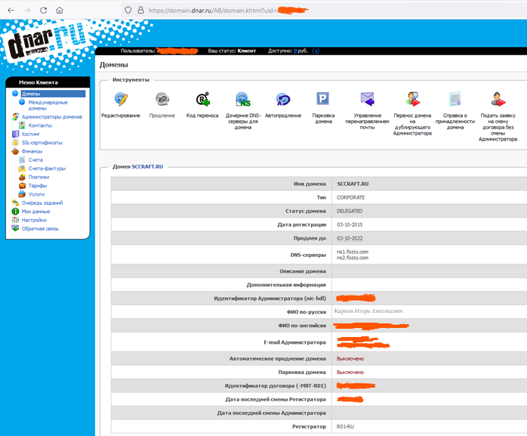

«A» запись субдомена dz-rip.pc.sccraft.ru

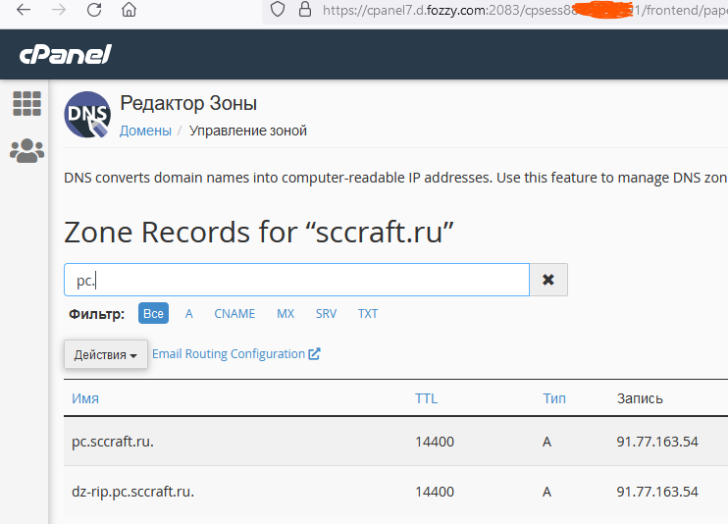

Особенности данной схемы:

1. Если прокси включён, но сервер API выключен, то клиент получит ошибку 502
2. Если сайт IIS, настроенный как прокси будет выключен, то IIS будет выдавать содержимое «Default Web Site», следовательно, в большинстве случаев при этом, клиент получит ошибку 404.

# Результаты выполнения программы

Программа тестировалась на следующих устройствах:

1. Windows 11 Subsystem for Android (только светлая тема)

[**Windows 11 Subsystem for Android**](https://www.comss.ru/page.php?id=9744)

**Главный экран (есть соединение)**

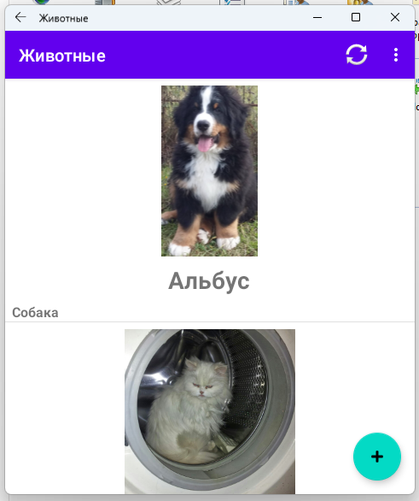

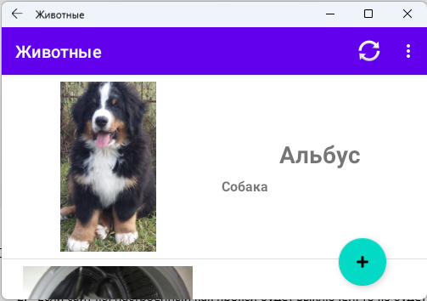

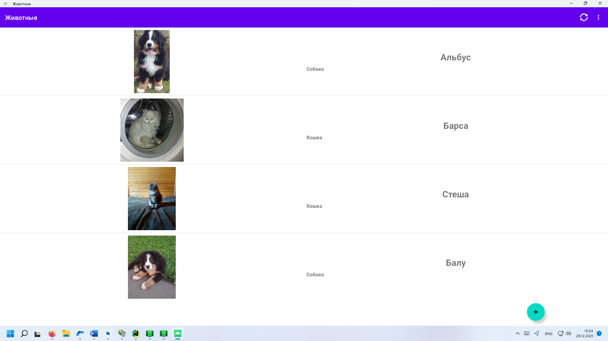

**Главный экран (нет соединения)**

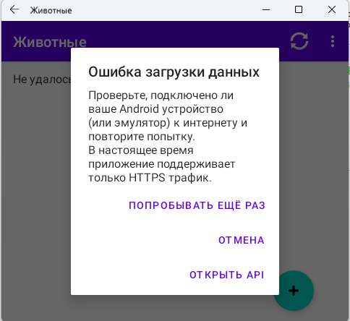

При нажатии кнопки «Попробовать ещё раз» будет выполнена повторная попытка.

Кнопка «Отмена закрывает диалог»

Кнопка «Открыть API» открывает сайт API (см. ЛР №6) в браузере.

**Информация о животном**

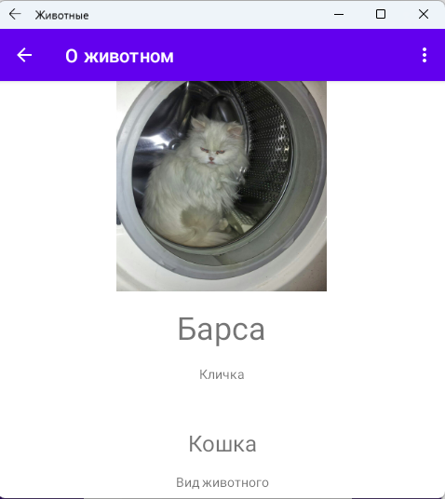

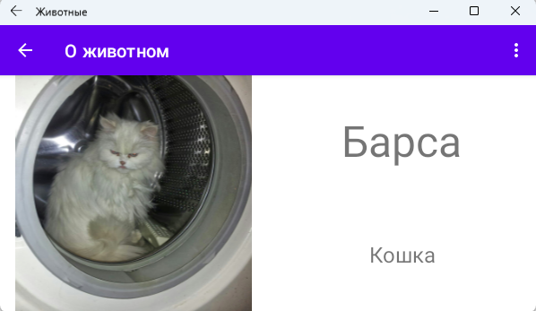

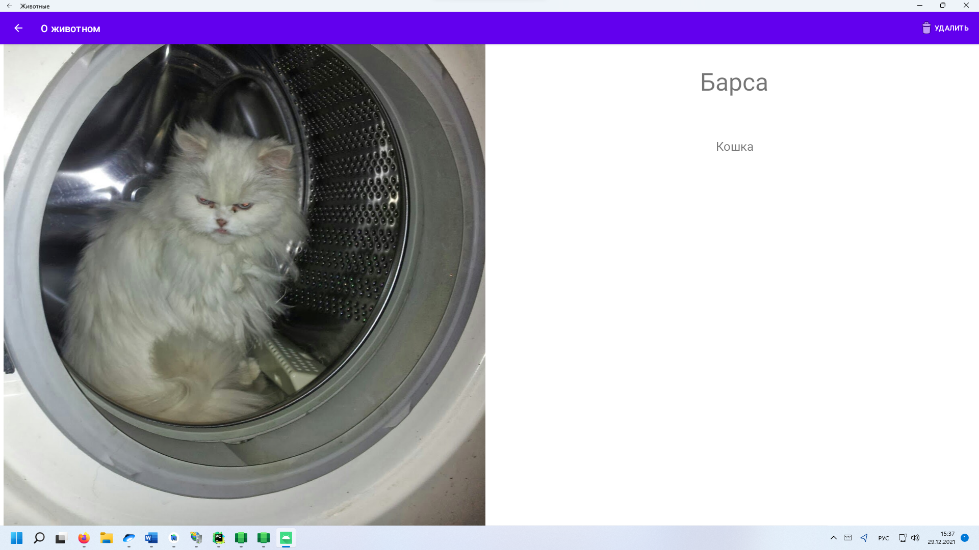

**О программе**

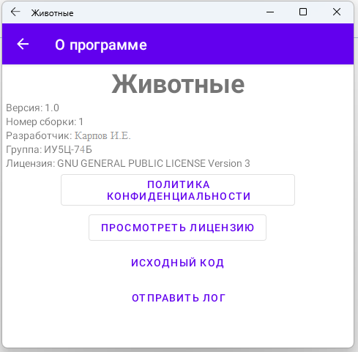

**Добавление животного (экран «Новое животное»)**

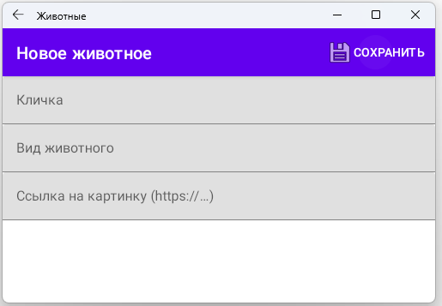

Данный экран позволяет добавить животное в приложение. Это изменение будет видно всем пользователям.

Например, можно добавить жирафа:

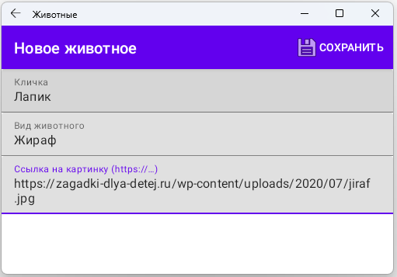

После нажатия кнопки «Сохранить» новое животное появится в конце списка после его обновления

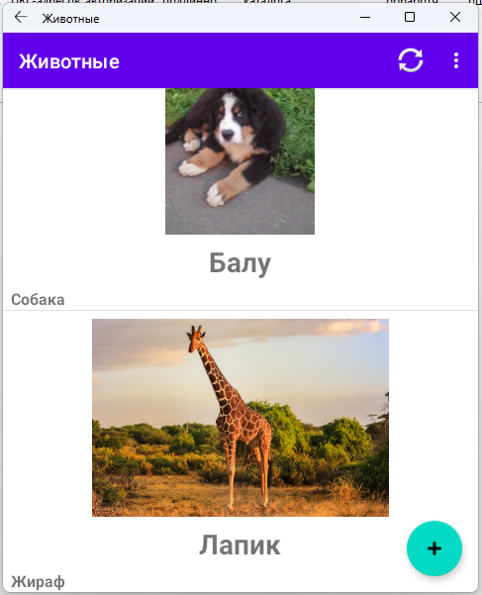

При нажатии на карточку можно просмотреть информацию о новом животном.

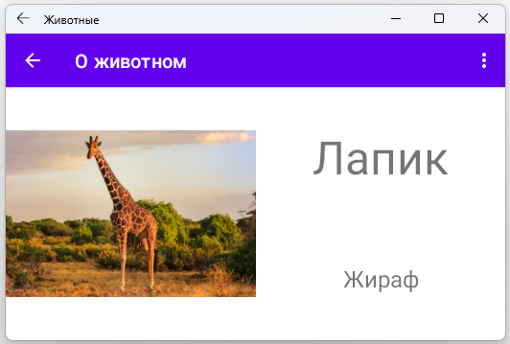

**Удаление животного**

Для удаления животного нужно нажать на кнопку или пункт меню «Удалить» (зависит от размера экрана). После нажатия кнопки необходимо подтвердить своё согласие на удаление в диалоговом окне.

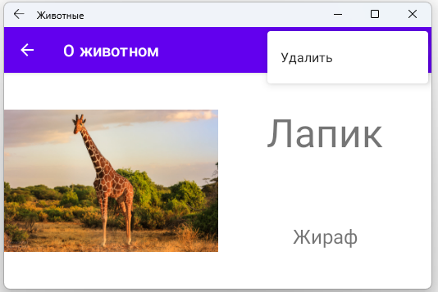

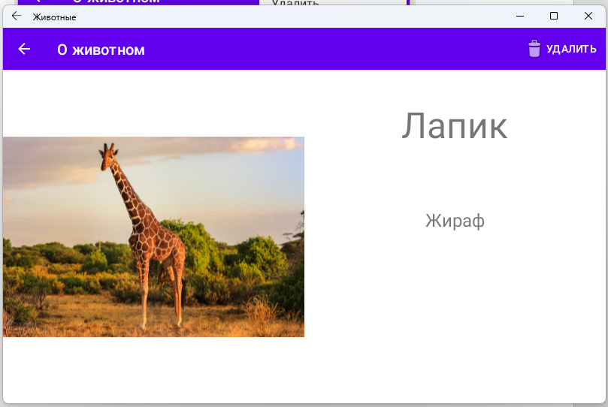

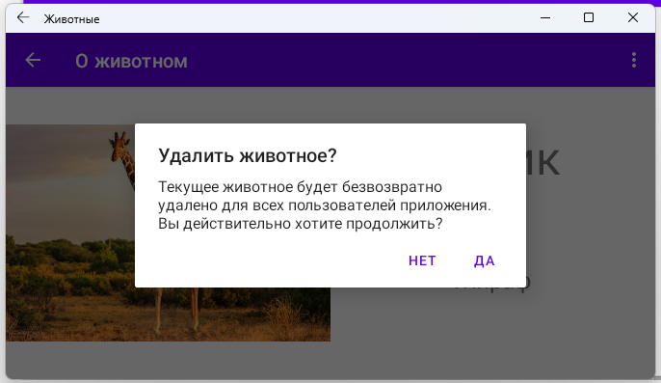

После нажатия кнопки «Да» животное удаляется из базы данных сервера.

Теперь рассмотрим работу приложения на реальном устройстве (описание скриншотов опущено, поскольку анологично):

**Лог, сформированный приложением (отправлен через другое приложение «VK Почта»)**

--------- beginning of perf  
12-28 15:10:30.168  8299  8299 I 100     : Open /data/app/~~P7_x_Xaa3unP9qxYFCJtvQ==/ru.sccraft.bmstulabs.rip.animals-Kg6rYxbp-kof17bsTKSC1g==/base.apk took:169ms  
12-28 15:13:05.815  8299 22034 I 111     :  OptJank - continuously drops frames:4  
12-28 15:13:05.856  8299 22034 I 111     :  OptJank - continuously drops frames:4  
12-28 15:13:05.954  8299 22034 I 111     :  OptJank - high percentage:0.6  
12-28 15:13:06.179  8299 22034 I 111     :  OptJank - high percentage:0.45  
12-28 15:13:06.190  8299 22034 I 111     :  OptJank - continuously drops frames:4  
12-28 15:13:06.429  8299 22034 I 111     :  OptJank - high percentage:0.55  
12-28 16:29:33.104 30135 30135 I 100     : Open /data/app/~~P7_x_Xaa3unP9qxYFCJtvQ==/ru.sccraft.bmstulabs.rip.animals-Kg6rYxbp-kof17bsTKSC1g==/base.apk took:161ms  
12-28 16:30:06.989 30136 30136 I 100     : Open /data/app/~~P7_x_Xaa3unP9qxYFCJtvQ==/ru.sccraft.bmstulabs.rip.animals-Kg6rYxbp-kof17bsTKSC1g==/base.apk took:161ms  
12-28 17:52:51.845 24320 24320 I 100     : Open /data/app/~~20ywJxdDXykRWUm5EUdWyQ==/ru.sccraft.bmstulabs.rip.animals-JLeGXq9Gq8ApHQZ_IZNl3w==/base.apk took:168ms  
12-28 17:53:22.116 24321 24321 I 100     : Open /data/app/~~20ywJxdDXykRWUm5EUdWyQ==/ru.sccraft.bmstulabs.rip.animals-JLeGXq9Gq8ApHQZ_IZNl3w==/base.apk took:164ms  
--------- beginning of main  
12-29 17:04:36.728 24321 24321 I abs.rip.animal: failed to find target package for overlay /system/product/overlay/ProductOverlay-oneplus-framework-res.apk  
12-29 17:04:36.728 24321 24321 I abs.rip.animal: failed to find target package for overlay /system/system_ext/overlay/CommonOverlay-oneplus-framework-res.apk  
12-29 17:04:36.728 24321 24321 I abs.rip.animal: failed to find target package for overlay /odm/overlay/OdmOverlay-oneplus-framework-res.apk  
12-29 17:04:36.733 24321 24321 I abs.rip.animal: failed to find target package for overlay /system/product/overlay/ProductOverlay-oneplus-framework-res.apk  
12-29 17:04:36.733 24321 24321 I abs.rip.animal: failed to find target package for overlay /system/system_ext/overlay/CommonOverlay-oneplus-framework-res.apk  
12-29 17:04:36.733 24321 24321 I abs.rip.animal: failed to find target package for overlay /odm/overlay/OdmOverlay-oneplus-framework-res.apk  
12-29 17:04:36.736 24321 24321 I abs.rip.animal: failed to find target package for overlay /system/product/overlay/ProductOverlay-oneplus-framework-res.apk  
12-29 17:04:36.736 24321 24321 I abs.rip.animal: failed to find target package for overlay /system/system_ext/overlay/CommonOverlay-oneplus-framework-res.apk  
12-29 17:04:36.736 24321 24321 I abs.rip.animal: failed to find target package for overlay /odm/overlay/OdmOverlay-oneplus-framework-res.apk  
--------- beginning of system  
12-29 17:04:36.774 24321 24321 D ViewRootImpl: support adaptive color gamut feature!  
12-29 17:04:36.775 24321 24321 V ViewRootImpl: The specified message queue synchronization  barrier token has not been posted or has already been removed  
12-29 17:04:36.817 24321 24321 D DecorView: onWindowFocusChangedFromViewRoot hasFocus: true, DecorView@9854550[MainActivity]  
12-29 17:04:36.818 24321 15732 I abs.rip.animal: Waiting for a blocking GC ProfileSaver  
12-29 17:04:36.821 24321 24321 D ViewRootImpl[MainActivity]: windowFocusChanged hasFocus=true inTouchMode=true  
12-29 17:04:36.821 24321 24321 D ActivityThread: pid:24321 tid:24321 doframe Callback  
12-29 17:04:36.847 24321 15723 W abs.rip.animal: Reducing the number of considered missed Gc histogram windows from 466 to 100  
12-29 17:04:36.847 24321 15732 I abs.rip.animal: WaitForGcToComplete blocked ProfileSaver on ProfileSaver for 29.881ms  
12-29 17:04:38.378 24321 12165 W abs.rip.animal: Accessing hidden method Lcom/android/org/conscrypt/ConscryptEngineSocket;->setUseSessionTickets(Z)V (greylist-max-q,core-platform-api, reflection, denied)  
12-29 17:04:38.378 24321 12165 W abs.rip.animal: Accessing hidden method Lcom/android/org/conscrypt/OpenSSLSocketImpl;->setUseSessionTickets(Z)V (greylist-max-q,core-platform-api, reflection, denied)  
12-29 17:04:38.378 24321 12165 W abs.rip.animal: Accessing hidden method Lcom/android/org/conscrypt/AbstractConscryptSocket;->setUseSessionTickets(Z)V (greylist-max-q, reflection, denied)  
12-29 17:04:38.378 24321 12165 W abs.rip.animal: Accessing hidden method Lcom/android/org/conscrypt/ConscryptEngineSocket;->setHostname(Ljava/lang/String;)V (greylist-max-q,core-platform-api, reflection, denied)  
12-29 17:04:38.378 24321 12165 W abs.rip.animal: Accessing hidden method Lcom/android/org/conscrypt/OpenSSLSocketImpl;->setHostname(Ljava/lang/String;)V (greylist-max-q,core-platform-api, reflection, denied)  
12-29 17:04:38.378 24321 12165 W abs.rip.animal: Accessing hidden method Lcom/android/org/conscrypt/AbstractConscryptSocket;->setHostname(Ljava/lang/String;)V (greylist-max-q, reflection, denied)  
12-29 17:04:38.378 24321 12165 W abs.rip.animal: Accessing hidden method Lcom/android/org/conscrypt/OpenSSLSocketImpl;->setAlpnProtocols([B)V (greylist-max-q,core-platform-api, reflection, denied)  
12-29 17:04:38.378 24321 12165 W abs.rip.animal: Accessing hidden method Lcom/android/org/conscrypt/AbstractConscryptSocket;->setAlpnProtocols([B)V (greylist-max-q, reflection, denied)  
12-29 17:04:38.569 24321 12165 W abs.rip.animal: Accessing hidden method Lcom/android/org/conscrypt/OpenSSLSocketImpl;->getAlpnSelectedProtocol()[B (greylist-max-q,core-platform-api, reflection, denied)  
12-29 17:04:38.569 24321 12165 W abs.rip.animal: Accessing hidden method Lcom/android/org/conscrypt/AbstractConscryptSocket;->getAlpnSelectedProtocol()[B (greylist-max-q, reflection, denied)  
12-29 17:04:38.840 24321 24321 I MainActivity: Данные из API успешно получены!  
12-29 17:04:38.879 24321 15748 W ExifInterface: Stop reading file since a wrong offset may cause an infinite loop: 0  
12-29 17:04:38.879 24321 15748 W ExifInterface: Stop reading file since a wrong offset may cause an infinite loop: 0  
12-29 17:04:39.802 24321 24321 D ViewRootImpl[MainActivity]: windowFocusChanged hasFocus=false inTouchMode=true  
12-29 17:04:40.685 24321 24321 I abs.rip.animal: failed to find target package for overlay /system/product/overlay/ProductOverlay-oneplus-framework-res.apk  
12-29 17:04:40.685 24321 24321 I abs.rip.animal: failed to find target package for overlay /system/system_ext/overlay/CommonOverlay-oneplus-framework-res.apk  
12-29 17:04:40.685 24321 24321 I abs.rip.animal: failed to find target package for overlay /odm/overlay/OdmOverlay-oneplus-framework-res.apk  
12-29 17:04:40.724 24321 24321 D ViewRootImpl: support adaptive color gamut feature!  
12-29 17:04:40.725 24321 24321 V ViewRootImpl: The specified message queue synchronization  barrier token has not been posted or has already been removed  
12-29 17:04:40.778 24321 24321 D DecorView: onWindowFocusChangedFromViewRoot hasFocus: true, DecorView@46081f0[MainActivity]  
12-29 17:04:40.779 24321 24321 D ViewRootImpl[MainActivity]: windowFocusChanged hasFocus=true inTouchMode=true  
12-29 17:04:40.779 24321 24321 D ActivityThread: pid:24321 tid:24321 doframe Callback  
12-29 17:04:40.894 24321 24321 I MainActivity: Данные из API успешно получены!  
12-29 17:04:41.787 24321 24321 D ViewRootImpl[MainActivity]: windowFocusChanged hasFocus=false inTouchMode=true  
12-29 17:04:58.732 24321 24321 I abs.rip.animal: failed to find target package for overlay /system/product/overlay/ProductOverlay-oneplus-framework-res.apk  
12-29 17:04:58.732 24321 24321 I abs.rip.animal: failed to find target package for overlay /system/system_ext/overlay/CommonOverlay-oneplus-framework-res.apk  
12-29 17:04:58.732 24321 24321 I abs.rip.animal: failed to find target package for overlay /odm/overlay/OdmOverlay-oneplus-framework-res.apk  
12-29 17:04:58.736 24321 24321 I abs.rip.animal: failed to find target package for overlay /system/product/overlay/ProductOverlay-oneplus-framework-res.apk  
12-29 17:04:58.736 24321 24321 I abs.rip.animal: failed to find target package for overlay /system/system_ext/overlay/CommonOverlay-oneplus-framework-res.apk  
12-29 17:04:58.736 24321 24321 I abs.rip.animal: failed to find target package for overlay /odm/overlay/OdmOverlay-oneplus-framework-res.apk  
12-29 17:04:58.738 24321 24321 I abs.rip.animal: failed to find target package for overlay /system/product/overlay/ProductOverlay-oneplus-framework-res.apk  
12-29 17:04:58.738 24321 24321 I abs.rip.animal: failed to find target package for overlay /system/system_ext/overlay/CommonOverlay-oneplus-framework-res.apk  
12-29 17:04:58.738 24321 24321 I abs.rip.animal: failed to find target package for overlay /odm/overlay/OdmOverlay-oneplus-framework-res.apk  
12-29 17:04:58.772 24321 24321 D ViewRootImpl: support adaptive color gamut feature!  
12-29 17:04:58.773 24321 24321 V ViewRootImpl: The specified message queue synchronization  barrier token has not been posted or has already been removed  
12-29 17:04:58.824 24321 24321 D ActivityThread: pid:24321 tid:24321 doframe Callback  
12-29 17:04:58.829 24321 24321 D DecorView: onWindowFocusChangedFromViewRoot hasFocus: true, DecorView@ec7f8c[MainActivity]  
12-29 17:04:58.830 24321 24321 D ViewRootImpl[MainActivity]: windowFocusChanged hasFocus=true inTouchMode=true  
12-29 17:04:58.859 24321 24321 E abs.rip.animal: Invalid ID 0x00000000.  
12-29 17:04:58.868 24321 24321 D ViewRootImpl: support adaptive color gamut feature!  
12-29 17:04:58.868 24321 24321 V ViewRootImpl: The specified message queue synchronization  barrier token has not been posted or has already been removed  
12-29 17:04:58.898 24321 24321 W Choreographer: Already have a pending vsync event.  There should only be one at a time.  
12-29 17:04:58.904 24321 24321 D ViewRootImpl[MainActivity]: windowFocusChanged hasFocus=false inTouchMode=true  
12-29 17:04:58.917 24321 24321 D DecorView: onWindowFocusChangedFromViewRoot hasFocus: true, DecorView@44e00f9[MainActivity]  
12-29 17:04:58.918 24321 24321 D ViewRootImpl[MainActivity]: windowFocusChanged hasFocus=true inTouchMode=true  
12-29 17:05:00.319 24321 15733 D OpenGLRenderer: endAllActiveAnimators on 0xb4000074caad91e0 (RippleDrawable) with handle 0xb4000073eaaf9160  
12-29 17:05:00.345 24321 24321 D DecorView: onWindowFocusChangedFromViewRoot hasFocus: true, DecorView@ec7f8c[MainActivity]  
12-29 17:05:00.346 24321 24321 D ViewRootImpl[MainActivity]: windowFocusChanged hasFocus=true inTouchMode=true  
12-29 17:05:00.420 24321 24321 D ViewRootImpl: support adaptive color gamut feature!  
12-29 17:05:00.420 24321 24321 V ViewRootImpl: The specified message queue synchronization  barrier token has not been posted or has already been removed  
12-29 17:05:00.445 24321 24321 W Choreographer: Already have a pending vsync event.  There should only be one at a time.  
12-29 17:05:00.446 24321 24321 D ViewRootImpl[MainActivity]: windowFocusChanged hasFocus=false inTouchMode=true  
12-29 17:05:00.456 24321 24321 D DecorView: onWindowFocusChangedFromViewRoot hasFocus: true, DecorView@3fef208[MainActivity]  
12-29 17:05:00.458 24321 24321 D ViewRootImpl[MainActivity]: windowFocusChanged hasFocus=true inTouchMode=true  
12-29 17:05:24.261 24321 15733 D OpenGLRenderer: endAllActiveAnimators on 0xb4000074caae28d0 (RippleDrawable) with handle 0xb4000073eaae6e90  
12-29 17:05:24.303 24321 24321 D DecorView: onWindowFocusChangedFromViewRoot hasFocus: true, DecorView@ec7f8c[MainActivity]  
12-29 17:05:24.305 24321 24321 D ViewRootImpl[MainActivity]: windowFocusChanged hasFocus=true inTouchMode=true  
12-29 17:05:25.392 24321 24321 D ViewRootImpl[MainActivity]: windowFocusChanged hasFocus=false inTouchMode=true  
12-29 17:05:25.825 24321 24321 D DecorView: onWindowFocusChangedFromViewRoot hasFocus: true, DecorView@ec7f8c[MainActivity]  
12-29 17:05:25.826 24321 24321 D ViewRootImpl[MainActivity]: windowFocusChanged hasFocus=true inTouchMode=true  
12-29 17:05:30.575 24321 24321 D ViewRootImpl: support adaptive color gamut feature!  
12-29 17:05:30.575 24321 24321 V ViewRootImpl: The specified message queue synchronization  barrier token has not been posted or has already been removed  
12-29 17:05:30.619 24321 24321 W Choreographer: Already have a pending vsync event.  There should only be one at a time.  
12-29 17:05:30.619 24321 24321 D ViewRootImpl[MainActivity]: windowFocusChanged hasFocus=false inTouchMode=true  
12-29 17:05:30.648 24321 24321 D DecorView: onWindowFocusChangedFromViewRoot hasFocus: true, DecorView@2e12d13[MainActivity]  
12-29 17:05:30.649 24321 24321 D ViewRootImpl[MainActivity]: windowFocusChanged hasFocus=true inTouchMode=true  
12-29 17:05:36.342 24321 24321 D ViewRootImpl[MainActivity]: windowFocusChanged hasFocus=false inTouchMode=true  
12-29 17:05:36.695 24321 24321 D DecorView: onWindowFocusChangedFromViewRoot hasFocus: true, DecorView@2e12d13[MainActivity]  
12-29 17:05:36.696 24321 24321 D ViewRootImpl[MainActivity]: windowFocusChanged hasFocus=true inTouchMode=true  
12-29 17:05:51.391 24321 15733 D OpenGLRenderer: endAllActiveAnimators on 0xb4000074cabce1f0 (RippleDrawable) with handle 0xb4000073eaae0140  
12-29 17:05:51.422 24321 24321 D DecorView: onWindowFocusChangedFromViewRoot hasFocus: true, DecorView@ec7f8c[MainActivity]  
12-29 17:05:51.423 24321 24321 D ViewRootImpl[MainActivity]: windowFocusChanged hasFocus=true inTouchMode=true  
12-29 17:05:53.741 24321 24321 I MainActivity: Данные из API успешно получены!  
12-29 17:06:00.399 24321 24321 I abs.rip.animal: failed to find target package for overlay /system/product/overlay/ProductOverlay-oneplus-framework-res.apk  
12-29 17:06:00.399 24321 24321 I abs.rip.animal: failed to find target package for overlay /system/system_ext/overlay/CommonOverlay-oneplus-framework-res.apk  
12-29 17:06:00.399 24321 24321 I abs.rip.animal: failed to find target package for overlay /odm/overlay/OdmOverlay-oneplus-framework-res.apk  
12-29 17:06:00.428 24321 24321 D ViewRootImpl: support adaptive color gamut feature!  
12-29 17:06:00.429 24321 24321 V ViewRootImpl: The specified message queue synchronization  barrier token has not been posted or has already been removed  
12-29 17:06:00.431 24321 24321 D ViewRootImpl[MainActivity]: windowFocusChanged hasFocus=false inTouchMode=true  
12-29 17:06:00.446 24321 24321 W Choreographer: Already have a pending vsync event.  There should only be one at a time.  
12-29 17:06:00.468 24321 24321 D DecorView: onWindowFocusChangedFromViewRoot hasFocus: true, DecorView@d109bd2[AnimalInfoActivity]  
12-29 17:06:00.470 24321 24321 D ViewRootImpl[AnimalInfoActivity]: windowFocusChanged hasFocus=true inTouchMode=true  
12-29 17:06:01.539 24321 24321 D ViewRootImpl[AnimalInfoActivity]: windowFocusChanged hasFocus=false inTouchMode=true  
12-29 17:06:01.581 24321 24321 D DecorView: onWindowFocusChangedFromViewRoot hasFocus: true, DecorView@ec7f8c[MainActivity]  
12-29 17:06:01.582 24321 24321 D ViewRootImpl[MainActivity]: windowFocusChanged hasFocus=true inTouchMode=true  
12-29 17:06:03.669 24321 24321 D ViewRootImpl[MainActivity]: windowFocusChanged hasFocus=false inTouchMode=true  
12-29 17:06:04.013 24321 24321 D DecorView: onWindowFocusChangedFromViewRoot hasFocus: true, DecorView@ec7f8c[MainActivity]  
12-29 17:06:04.014 24321 24321 D ViewRootImpl[MainActivity]: windowFocusChanged hasFocus=true inTouchMode=true  
12-29 17:06:06.286 24321 24321 I abs.rip.animal: failed to find target package for overlay /system/product/overlay/ProductOverlay-oneplus-framework-res.apk  
12-29 17:06:06.286 24321 24321 I abs.rip.animal: failed to find target package for overlay /system/system_ext/overlay/CommonOverlay-oneplus-framework-res.apk  
12-29 17:06:06.286 24321 24321 I abs.rip.animal: failed to find target package for overlay /odm/overlay/OdmOverlay-oneplus-framework-res.apk  
12-29 17:06:06.292 24321 24321 I abs.rip.animal: failed to find target package for overlay /system/product/overlay/ProductOverlay-oneplus-framework-res.apk  
12-29 17:06:06.292 24321 24321 I abs.rip.animal: failed to find target package for overlay /system/system_ext/overlay/CommonOverlay-oneplus-framework-res.apk  
12-29 17:06:06.292 24321 24321 I abs.rip.animal: failed to find target package for overlay /odm/overlay/OdmOverlay-oneplus-framework-res.apk  
12-29 17:06:06.295 24321 24321 I abs.rip.animal: failed to find target package for overlay /system/product/overlay/ProductOverlay-oneplus-framework-res.apk  
12-29 17:06:06.295 24321 24321 I abs.rip.animal: failed to find target package for overlay /system/system_ext/overlay/CommonOverlay-oneplus-framework-res.apk  
12-29 17:06:06.295 24321 24321 I abs.rip.animal: failed to find target package for overlay /odm/overlay/OdmOverlay-oneplus-framework-res.apk  
12-29 17:06:06.335 24321 24321 D ViewRootImpl: support adaptive color gamut feature!  
12-29 17:06:06.383 24321 24321 V ViewRootImpl: The specified message queue synchronization  barrier token has not been posted or has already been removed  
12-29 17:06:06.425 24321 24321 W Choreographer: Already have a pending vsync event.  There should only be one at a time.  
12-29 17:06:06.496 24321 24321 D DecorView: onWindowFocusChangedFromViewRoot hasFocus: true, DecorView@dcfd00e[MainActivity]  
12-29 17:06:06.542 24321 24321 D ViewRootImpl[MainActivity]: windowFocusChanged hasFocus=true inTouchMode=true  
12-29 17:06:06.542 24321 24321 I MainActivity: Данные из API успешно получены!  
12-29 17:06:06.560 24321 15748 W ExifInterface: Stop reading file since a wrong offset may cause an infinite loop: 0  
12-29 17:06:06.560 24321 15748 W ExifInterface: Stop reading file since a wrong offset may cause an infinite loop: 0  
12-29 17:06:06.606 24321 15725 W System  : A resource failed to call release.   
12-29 17:06:06.607 24321 15725 I chatty  : uid=10030(ru.sccraft.bmstulabs.rip.animals) FinalizerDaemon identical 1 line  
12-29 17:06:06.607 24321 15725 W System  : A resource failed to call release.   
12-29 17:06:12.666 24321 24321 D ViewRootImpl[MainActivity]: windowFocusChanged hasFocus=false inTouchMode=true  
12-29 17:06:17.317 24321 24321 D ViewRootImpl[AnimalInfoActivity]: windowFocusChanged hasFocus=false inTouchMode=true  
12-29 17:06:25.033 24321 24321 I TextInputLayout: EditText added is not a TextInputEditText. Please switch to using that class instead.  
12-29 17:06:25.054 24321 24321 D ViewRootImpl: support adaptive color gamut feature!  
12-29 17:06:25.042 24321 24321 I chatty  : uid=10030(ru.sccraft.bmstulabs.rip.animals) identical 1 line  
12-29 17:06:25.049 24321 24321 I TextInputLayout: EditText added is not a TextInputEditText. Please switch to using that class instead.  
12-29 17:06:25.055 24321 24321 V ViewRootImpl: The specified message queue synchronization  barrier token has not been posted or has already been removed  
12-29 17:06:25.058 24321 24321 D ViewRootImpl[MainActivity]: windowFocusChanged hasFocus=false inTouchMode=true  
12-29 17:06:25.090 24321 24321 W Choreographer: Already have a pending vsync event.  There should only be one at a time.  
12-29 17:06:25.105 24321 24321 D DecorView: onWindowFocusChangedFromViewRoot hasFocus: true, DecorView@7348cc8[AnimalAddActivity]  
12-29 17:06:25.106 24321 24321 D ViewRootImpl[AnimalAddActivity]: windowFocusChanged hasFocus=true inTouchMode=true  
12-29 17:06:29.240 24321 24321 I abs.rip.animal: failed to find target package for overlay /system/product/overlay/ProductOverlay-oneplus-framework-res.apk  
12-29 17:06:29.240 24321 24321 I abs.rip.animal: failed to find target package for overlay /system/system_ext/overlay/CommonOverlay-oneplus-framework-res.apk  
12-29 17:06:29.240 24321 24321 I abs.rip.animal: failed to find target package for overlay /odm/overlay/OdmOverlay-oneplus-framework-res.apk  
12-29 17:06:29.245 24321 24321 I abs.rip.animal: failed to find target package for overlay /system/product/overlay/ProductOverlay-oneplus-framework-res.apk  
12-29 17:06:29.245 24321 24321 I abs.rip.animal: failed to find target package for overlay /system/system_ext/overlay/CommonOverlay-oneplus-framework-res.apk  
12-29 17:06:29.245 24321 24321 I abs.rip.animal: failed to find target package for overlay /odm/overlay/OdmOverlay-oneplus-framework-res.apk  
12-29 17:06:29.249 24321 24321 I abs.rip.animal: failed to find target package for overlay /system/product/overlay/ProductOverlay-oneplus-framework-res.apk  
12-29 17:06:29.249 24321 24321 I abs.rip.animal: failed to find target package for overlay /system/system_ext/overlay/CommonOverlay-oneplus-framework-res.apk  
12-29 17:06:29.249 24321 24321 I abs.rip.animal: failed to find target package for overlay /odm/overlay/OdmOverlay-oneplus-framework-res.apk  
12-29 17:06:29.299 24321 24321 I TextInputLayout: EditText added is not a TextInputEditText. Please switch to using that class instead.  
12-29 17:06:29.312 24321 24321 D ViewRootImpl: support adaptive color gamut feature!  
12-29 17:06:29.312 24321 24321 V ViewRootImpl: The specified message queue synchronization  barrier token has not been posted or has already been removed  
12-29 17:06:29.345 24321 24321 W Choreographer: Already have a pending vsync event.  There should only be one at a time.  
12-29 17:06:29.396 24321 24321 D DecorView: onWindowFocusChangedFromViewRoot hasFocus: true, DecorView@53b5718[AnimalAddActivity]  
12-29 17:06:29.397 24321 24321 D ViewRootImpl[AnimalAddActivity]: windowFocusChanged hasFocus=true inTouchMode=true  
12-29 17:06:34.551 24321 24321 I MainActivity: Данные из API успешно получены!  
12-29 17:06:34.617 24321 15725 W System  : A resource failed to call release.   
12-29 17:06:34.617 24321 15725 I chatty  : uid=10030(ru.sccraft.bmstulabs.rip.animals) FinalizerDaemon identical 1 line  
12-29 17:06:34.617 24321 15725 W System  : A resource failed to call release.   
12-29 17:06:35.845 24321 24321 E abs.rip.animal: Invalid ID 0x00000000.  
12-29 17:06:35.863 24321 24321 D ViewRootImpl: support adaptive color gamut feature!  
12-29 17:06:35.864 24321 24321 V ViewRootImpl: The specified message queue synchronization  barrier token has not been posted or has already been removed  
12-29 17:06:35.894 24321 24321 W Choreographer: Already have a pending vsync event.  There should only be one at a time.  
12-29 17:06:44.053 24321 24321 D ViewRootImpl[AboutActivity]: windowFocusChanged hasFocus=false inTouchMode=true  
12-29 17:06:44.067 24321 24321 D DecorView: onWindowFocusChangedFromViewRoot hasFocus: true, DecorView@5bc951a[MainActivity]  
12-29 17:06:44.068 24321 24321 D ViewRootImpl[MainActivity]: windowFocusChanged hasFocus=true inTouchMode=true  
12-29 17:06:49.149 24321 24321 D ViewRootImpl: support adaptive color gamut feature!  
12-29 17:06:49.149 24321 24321 V ViewRootImpl: The specified message queue synchronization  barrier token has not been posted or has already been removed  
12-29 17:06:49.174 24321 24321 W Choreographer: Already have a pending vsync event.  There should only be one at a time.  
12-29 17:06:49.178 24321 24321 D ViewRootImpl[MainActivity]: windowFocusChanged hasFocus=false inTouchMode=true  
12-29 17:06:49.198 24321 24321 D ViewRootImpl[PopupWindow:8df6ed8]: windowFocusChanged hasFocus=true inTouchMode=true  
12-29 17:06:49.801 24321 24321 D ViewRootImpl: support adaptive color gamut feature!  
12-29 17:06:49.802 24321 24321 V ViewRootImpl: The specified message queue synchronization  barrier token has not been posted or has already been removed  
12-29 17:06:49.805 24321 24321 D ViewRootImpl[PopupWindow:8df6ed8]: windowFocusChanged hasFocus=false inTouchMode=true  
12-29 17:06:49.820 24321 24321 W Choreographer: Already have a pending vsync event.  There should only be one at a time.  
12-29 17:06:49.832 24321 24321 D DecorView: onWindowFocusChangedFromViewRoot hasFocus: true, DecorView@c373efe[AboutActivity]  
12-29 17:06:49.833 24321 24321 D ViewRootImpl[AboutActivity]: windowFocusChanged hasFocus=true inTouchMode=true  
12-29 17:06:50.067 24321 15733 D OpenGLRenderer: endAllActiveAnimators on 0xb4000074cabbafc0 (MenuPopupWindow$MenuDropDownListView) with handle 0xb4000073eaaf6850  
12-29 17:06:53.562 24321 24321 D ViewRootImpl[AboutActivity]: windowFocusChanged hasFocus=false inTouchMode=true  
12-29 17:06:53.918 24321 24321 D DecorView: onWindowFocusChangedFromViewRoot hasFocus: true, DecorView@c373efe[AboutActivity]  
12-29 17:06:53.919 24321 24321 D ViewRootImpl[AboutActivity]: windowFocusChanged hasFocus=true inTouchMode=true  
12-29 17:07:02.201 24321 24321 D ViewRootImpl[AboutActivity]: windowFocusChanged hasFocus=false inTouchMode=true  
12-29 17:07:28.546 24321 24321 D DecorView: onWindowFocusChangedFromViewRoot hasFocus: true, DecorView@c373efe[AboutActivity]  
12-29 17:07:28.547 24321 24321 D ViewRootImpl[AboutActivity]: windowFocusChanged hasFocus=true inTouchMode=true  
null

**Лог API**

"A:\sasha\YandexDisk\МГТУ\7-й семестр\РИП\ЛР\Py\LAB_6\venv\Scripts\python.exe" "A:/sasha/YandexDisk/МГТУ/7-й семестр/РИП/ЛР/Py/LAB_6/manage.py" runserver 8000

Performing system checks...

Watching for file changes with StatReloader

System check identified no issues (0 silenced).

December 29, 2021 - 17:51:09

Django version 3.2.9, using settings 'LAB_6.settings'

Starting development server at http://127.0.0.1:8000/

Quit the server with CTRL-BREAK.

[29/Dec/2021 17:55:18] "GET /animals HTTP/1.1" 301 0

[29/Dec/2021 17:55:19] "GET /animals/ HTTP/1.1" 200 525

Bad Request: /animals/

[29/Dec/2021 17:55:48] "POST /animals/ HTTP/1.1" 400 61

Bad Request: /animals/

[29/Dec/2021 17:56:06] "POST /animals/ HTTP/1.1" 400 61

[29/Dec/2021 17:56:33] "GET /animals HTTP/1.1" 301 0

[29/Dec/2021 17:56:33] "GET /animals/ HTTP/1.1" 200 525

[29/Dec/2021 17:57:29] "POST /animals/ HTTP/1.1" 201 156

[29/Dec/2021 17:57:39] "GET /animals HTTP/1.1" 301 0

[29/Dec/2021 17:57:39] "GET /animals/ HTTP/1.1" 200 682

[29/Dec/2021 17:57:50] "DELETE /animals/13/ HTTP/1.1" 204 0

[29/Dec/2021 17:57:53] "GET /animals HTTP/1.1" 301 0

[29/Dec/2021 17:57:53] "GET /animals/ HTTP/1.1" 200 525